Mineral Parcel Mapping Project
August 2010 Progress / Final Report
Submitted to the West Virginia State Tax Department, Property Tax Division (PTD)
In support of the Mined Minerals GIS

Introduction
The West Virginia GIS Technical Center (WVGISTC) contributed to the West Virginia State Tax Department, Property Tax Division (PTD) Mined Minerals GIS project by spatially locating, digitizing and attributing mineral parcels/accounts with known tax map locations (Geocode 3 level). In addition to the Geocode 3 parcel processing, the WVGISTC georeferenced the mineral/coal map images for all West Virginia counties that have them. This report details mapping and related tasks that were performed from late spring to early autumn of 2010. We begin with a discussion of the most recent activities before moving to the overall project goals and accomplishments.

Accomplishments during August 2010:
- Completed mapping and final QC for 6 remaining counties
- Finished final review for and delivered 10 additional mineral mapping county data sets
- Prepared draft final report for project
- Completed draft training manual detailing procedures used in mineral parcel mapping production

Mapping and QC tasks were completed during August 2010 for the final 6 assigned counties still underway or pending in July (Mineral, Pleasants, Putnam, Randolph, Taylor, and Upshur). An additional 10 county data sets were delivered to the PTD via the WVGISTC secure ftp site. This brings to 17 the total number of delivered counties at month's end. The remaining 7 county data sets were delivered by late September following final administrative review of data and documentation. See the following sections and tables for metrics of production.

A comprehensive (50+ pages) training manual for georeferencing and mineral parcel mapping was created during August by WVGISTC staff in order to capture the procedures used. This document will serve as a useful reference for how tasks were carried out as well as a means by which future technicians may be trained to perform this work. The training manual will be submitted to the PTD along with this document.

Review of overall project accomplishments
- Determined mineral parcel mapping procedures and compiled production steps into a flow chart which was reviewed internally and at the PTD
- Established a checklist for quality control review
- Trained 6 technicians in mapping and quality control procedures
- Completed mapping and final QC for 24 counties (4690 parcels total)
- Enhanced 3307 parcels from Geocode 3 to Geocode 4 status, 70.5% of those assigned
- Georectified mineral maps (580 images total) for 43 counties
- Created detailed documents with parcel mapping status and supporting information
- Created a training manual detailing the course of the project
- Invested a total of 1,102 person hours in completing project

Process Development
Preliminary meetings and training for this project occurred throughout March, April, and May of 2010 in Morgantown and in Charleston. There was also extensive correspondence via email, phone calls, and online meetings to determine best practices for enhancing Geocode 3 parcels to Geocode 4 parcels. Data for 13 counties (representing 2691 Geocode 3 parcels) was delivered to WVGISTC by May 21, 2010. Delivery of additional county specific information continued through July 30, 2010. Please see Appendix A for a full list of county delivery dates from PTD to WVGISTC. WVGISTC summer staff were trained in georeferencing procedures by May 21, 2010.

Parameters for georeferencing procedures were set by May 21, 2010, and this facet of the project moved forward immediately while mineral parcel mapping procedures were compiled. An outline of procedures was developed by early June for processing the Geocode 3 parcels. Developing specific procedures and guidelines for the enhancement of the Geocode 3 parcels was complicated by varying conditions of mapability and a lack of standardization of data provided by counties. Procedures were refined during the processing of the first few counties of the project. There were also variations within the county cadastral (GIS) layer data provided. By June 16, 2010 the WVGISTC produced a flow chart that captured the procedures used to map mineral parcels. This flow chart was reviewed internally by all staff and externally by Tyler Bragg at the PTD (see Figure 1).
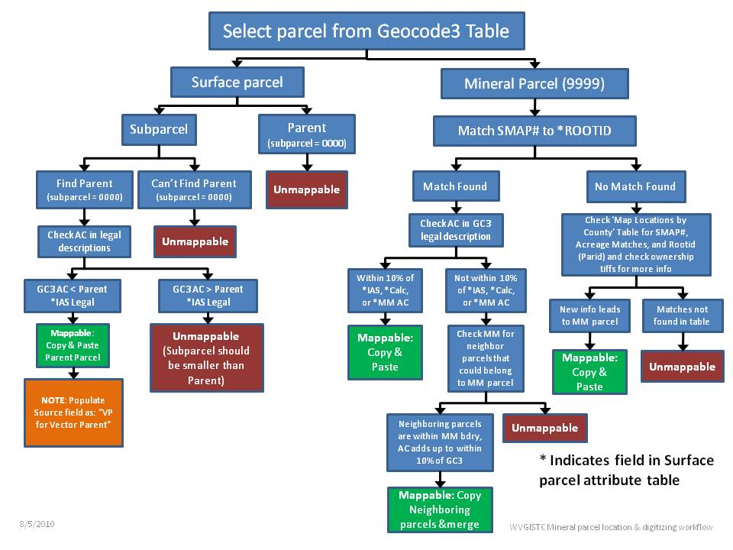
Figure 1. Geocode 3 processing flow chart

Georeferencing
All georeferencing of mineral tax map images was completed by June 25, 2010. Several counties required some edits after this date (Mingo and Randolph). The majority of georeferencing, georeferencing quality control, and recording of the georeferenced images root mean square error were, however, completed. A total of 580 map images covering portions of 43 counties were georeferenced.

Mineral Parcel Mapping
Production of Geocode 4 level mineral parcel map products was begun on June 3, 2010 and completed on August 8, 2010. Each county was processed according to the availability of updated or recent county cadastral layers (Appendix A provides the dates on which new county data were received) and ranking in the county priority list provided by PTD. As new updated county data was made available to WVGISTC, it was processed according to its location in the priority ranking document.

Status for each step was tracked in a variety of spread sheets and documents and includes dates of commencement and completion, technician, and time metrics for each county. A complete list of tracking documents can be found in Appendix B. Progress reports were submitted on a monthly basis and separate interim reports were provided with each county delivery.

Quality Control
Quality control procedures were developed for both the georeferenced images and the digitization of mineral parcels. Georeferenced maps were validated by a more experienced technician reviewing each map georeferenced and creating a detailed list of maps that should then be looked at a third time. A third technician examined noted maps and consulted with full time staff personnel on several issues for quality control of georeferenced images. Digitization quality control took on a two step process due to the nature and repetitively of the project. As technicians were using so many numbers during the mapping process, it was discovered early that it was quite easy to mix up one or two numbers. This most often resulted in a number of parcels not being collected that should have. Therefore, quality control 1 (QC1) was introduced into the process which contains validation of each parcel’s map status in the Geocode 3 list, by a different technician than the initial mapper. A detailed description of QC1 can be found in the training document.

Similar to QC1, quality control step 2 (QC2) validated many parcels in a county, but not all of them. This step included spatial validation and acreage calculations to highlight potentially incorrectly mapped features. QC2 also included the parsing of the RootId into its individual fields, compilation of the interim county report, and review of problem parcels and documentation. A detailed description of QC 2 procedures can also be found in the training document.

After QC2 review, metadata was created for each county and the component of the deliverables for each county were collected. Each county then received a final review by a full time staff member of WVGISTC before being uploaded to the secure FTP site and delivered to PTD.

Upon PTD review, several counties needed some adjustments (Wyoming and Mingo) and a complete list of counties with delivery dates, acceptance dates, and resubmission dates is included in Appendix C.

Metadata
FGDC metadata has been created for each shapefile submitted to PTD as well as for the mineral map raster images. Each new shapefile created for PTD has a corresponding metadata text file; however, there is one metadata file for raster images (TIFFs) and the WV Mineral Map Index. Metadata created for each shapefile that was submitted was modeled and consisted of all the necessary information that met the criteria of The Federal Geographic Data Committee’s Content Standards for Digital Geospatial Metadata. This included information on its identification, the data quality, the spatial data organization, spatial reference, entities and attributes, distribution and the metadata reference information. It was then customized to each shapefile accordingly. Metadata created for the Mineral Map Index and the Raster Images followed the same procedures by adhering to the format criteria and standards as the county parcel shapefiles. They were also customized accordingly to the type of information for each product.

Table 1. WVGISTC Mineral Parcel Mapping Metrics for June - August 2010
 | County | Mapping | QC1 | QC2 | Number of  Parcels | Parcels  Mapped
1 | Brooke | 6/25/2010 | 6/28/2010 | 7/19/2010 | 2 | 1
2 | Cabell | 7/1/2010 | 7/7/2010 | 7/21/2010 | 409 | 159
3 | Doddridge | 6/28/2010 | 6/29/2010 | 7/13/2010 | 18 | 12
4 | Fayette | 6/16/2010 | 6/29/2010 | 7/9/2010 | 137 | 75
5 | Gilmer | 6/18/2010 | 6/25/2010 | 7/13/2010 | 278 | 201
6 | Hampshire | 7/20/2010 | 7/21/2010 | 7/23/2010 | 126 | 43
7 | Hancock | 6/28/2010 | 6/29/2010 | 7/20/2010 | 31 | 22
8 | Harrison | 6/24/2010 | 6/25/2010 | 7/14/2010 | 94 | 44
9 | Marshall | 6/25/2010 | 6/29/2010 | 7/19/2010 | 165 | 130
10 | Mason | 7/14/2010 | 7/19/2010 | 7/26/2010 | 184 | 131
11 | Mineral | 7/15/2010 | 7/21/2010 | 8/2/2010 | 643 | 615
12 | Mingo | 6/17/2010 | 6/23/2010 | 7/6/2010 | 281 | 172
13 | Morgan | 7/14/2010 | 7/19/2010 | 7/22/2010 | 9 | 3
14 | Nicholas | 6/23/2010 | 7/9/2010 | 7/12/2010 | 222 | 80
15 | Pleasants | 7/28/2010 | 7/28/2010 | 8/3/2010 | 92 | 73
16 | Pocahontas | 6/25/2010 | 6/28/2010 | 7/21/2010 | 35 | 26
17 | Putnam | 8/3/2010 | 8/4/2010 | 8/5/2010 | 56 | 30
18 | Randolph | 7/9/2010 | 7/21/2010 | 8/6/2010 | 973 | 790
19 | Taylor | 7/29/2010 | 7/30/2010 | 8/3/2010 | 144 | 95
20 | Tucker | 7/13/2010 | 7/19/2010 | 7/22/2010 | 94 | 47
21 | Upshur | 8/2/2010 | 8/5/2010 | 8/6/2010 | 106 | 82
22 | Webster | 6/21/2010 | 6/29/2010 | 7/15/2010 | 389 | 326
23 | Wetzel | 6/24/2010 | 6/24/2010 | 7/15/2010 | 72 | 69
24 | Wyoming | 6/14/2010 | 6/24/2010 | 6/25/2010 | 130 | 81
 |  |  |  | Totals: | 4690 | 3307
* | The number of parcels mapped is recorded after the second QC cycle.

Table 2. Schedule for report submission
Report Name | Report Type | Date Submitted
May 2010 Progress Report | Monthly | June 25, 2010
Wyoming County Interim Report | County | July 1, 2010
June 2010 Progress Report | Monthly | July 13, 2010
Mingo County Interim Report | County | July 16, 2010
Nicholas County Interim Report | County | July 23, 2010
Brooke County Interim Report | County | July 23, 2010
Hancock County Interim Report | County | July 23, 2010
Fayette County Interim Report | County | July 23, 2010
Gilmer County Interim Report | County | July 29,2010
Webster County Interim Report | County | August 5, 2010
Doddridge County Interim Report | County | August 5, 2010
Harrison County Interim Report | County | August 5, 2010
Wetzel County Interim Report | County | August 6, 2010
July 2010 Progress Report | Monthly | August 23, 2010
Marshall County Interim Report | County | August 11, 2010
Cabell County Interim Report | County | August 23, 2010
Mason County Interim Report | County | August 23, 2010
Pocahontas County Interim Report | County | August 23, 2010
Tucker County Interim Report | County | August 30, 2010
Morgan County Interim Report | County | August 30, 2010
Hampshire County Interim Report | County | September 8, 2010
Randolph County Interim Report | County | September 8, 2010
Mineral County Interim Report | County | September 16, 2010
Pleasants County Interim Report | County | September 27, 2010
Taylor County Interim Report | County | September 27, 2010
Upshur County Interim Report | County | September 27, 2010
Putman County Interim Report | County | September 27, 2010
August 2010 Progress / Project Summary | Monthly / Final | September 27, 2010

Additional information
All county parcel mapping and georeferencing data and document files, with the exception of georeferenced mineral maps in counties for which geocode 3 parcels were not provided, were submitted prior to the issuance of this report. The balance of georeferenced mineral maps will be submitted separately using an external hard drive.

The WVGISTC will, to the best of our ability, and in the context of other ongoing projects, respond promptly to requests for clarification regarding any submitted items, and will review and, if possible, correct any errors on our part brought to our attention by the PTD.

Additional mineral parcel mapping or related work will be performed upon request and on a county by county basis. The WVGISTC is currently processing geocode 3 parcels for Boone County, WV. This work will be handled separately from 24 counties contracted for summer 2010, but the same procedures, deliverables and reporting/ documentation requirements will be followed unless we are instructed to do otherwise.

Contact Information
This report was prepared by Eric Hopkins, Jennifer Smith and Lindsey Felton.

For questions or comments, please contact:

Eric Hopkins, Lead GIS Specialist
WV GIS Technical Center
WVU Dept. of Geol. & Geog.
Eric.Hopkins@mail.wvu.edu
(304)293-9463

or

Lindsey Felton
GRA, WV GIS Technical Center
Student Project Lead
lfelton28@gmail.com
(304)293-0557

Appendix A: Dates new data was delivered from PTD to WVGISTC

New County Data Submitted to WVGISTC
County | Date Received by WVGISTC
Gilmer | 5/5/2010
Wetzel | 5/5/2010
Mingo | 5/7/2010
Webster | 5/7/2010
Brooke | 5/13/2010
Fayette | 5/13/2010
Marshall | 5/13/2010
Pendleton | 5/13/2010
Pocahontas | 5/13/2010
Commencement of Project | 5/17/2010
Harrison | 5/17/2010
Wyoming | 5/21/2010
Randolph | 5/24/2010
Nicholas | 5/26/2010
Mineral | 5/26/2010
Doddridge | 5/11/2010
Hancock | 6/1/2010
Cabell | 6/25/2010
Tucker | 6/29/2010
Mason | 7/11/2010
Pleasants | 7/23/2010
Taylor | 7/27/2010
Upshur | 7/29/2010
Putnam | 7/30/2010

Appendix B: List of reference documents

 | Description | Date Submitted
Training Manual Document (Draft) | Includes the technical processes and steps for creating and maintaining the products delivered to the PTD. | 9/28/2010
County Time tracking Spreadsheet | Contains total tracked time spent on each county during the course of project. | 9/30/2010
County Digitizing Spreadsheet | Contains time spent on the digitization of the counties ‘9999’ and ‘surf’ parcels. | 9/30/2010
Mineral Maps Inventory Spreadsheet | List of mineral maps by county and district, with scanned status, number of maps | 9/30/2010
Missing Maps Spreadsheet | List of maps expected in but missing from county data set delivered to us | 9/30/2010
Updated Priority List Spreadsheet | List of counties by prioroty | 9/30/2010

Appendix C: Schedule of Deliverables
Table of Products Delivered
 |  |  | Date Delivered to PTD | Date Accepted by PTD | Date Edited | Re-submission Date | Final PTD Approval Date
Brooke County |  |  | 7/23/2010 | 8/03/2010 |  |  | 8/03/2010
 | Documents | Yes
 | Shapefiles | Yes
 | Tiffs | yes
Cabell County |  |  | 8/23/2010 | 9/3/2010 |  |  | 9/3/2010
 | Documents | Yes
 | Shapefiles | Yes
 | Tiffs | NA
Doddridge County |  |  | 8/05/2010 | 8/13/2010 |  |  | 8/13/2010
 | Documents | Yes
 | Shapefiles | Yes
 | Tiffs | Yes
Fayette County |  |  | 7/23/2010 | 8/03/2010 |  |  | 8/3/2010
 | Documents | Yes
 | Shapefiles | Yes
 | Tiffs | Yes
Gilmer County |  |  | 7/29/2010 | 8/03/2010 |  |  | 8/3/2010
 | Documents | Yes
 | Shapefiles | Yes
 | Tiffs | Yes
Hampshire County |  |  | 9/8/2010 | 9/15/2010 |  |  | 9/15/2010
 | Documents | Yes
 | Shapefiles | Yes
 | Tiffs | NA
Hancock County |  |  | 7/23/2010 | 8/03/2010 |  |  | 8/3/2010
 | Documents | Yes
 | Shapefiles | Yes
 | Tiffs | Yes
Harrison County |  |  | 8/05/2010 | 8/13/2010 |  |  | 8/13/2010
 | Documents | Yes
 | Shapefiles | Yes
 | Tiffs | Yes

Marshall County |  |  | 8/11/2010 | 8/13/2010 |  |  | 8/13/2010
 | Documents
 | Shapefiles
 | Tiffs
Mason County |  |  | 8/23/2010 | 9/3/2010 |  |  | 9/3/2010
 | Documents | Yes
 | Shapefiles | Yes
 | Tiffs | Yes
Mineral County |  |  | 9/16/2010 | 9/29/2010 |  |  | 9/29/2010
 | Documents | Yes
 | Shapefiles | Yes
 | Tiffs | Yes
Mingo County |  |  | 7/16/2010 | 7/19/2010 | 7/23/2010 | 7/23/2010 | 7/23/2010
 | Documents | Yes
 | Shapefiles | Yes
 | Tiffs | Yes
Morgan County |  |  | 8/30/2010 | 9/3/2010 |  |  | 9/3/2010
 | Documents | Yes
 | Shapefiles | Yes
 | Tiffs | NA
Nicholas County |  |  | 7/23/2010 | 8/03/2010 |  |  | 8/3/2010
 | Documents | Yes
 | Shapefiles | Yes
 | Tiffs | yes
Pleasants County |  |  | 9/27/2010 | 9/28/2010 |  |  | 9/29/2010
 | Documents
 | Shapefiles
 | Tiffs
Pocahontas County |  |  | 8/23/2010 | 9/3/2010 |  |  | 9/3/2010
 | Documents | Yes
 | Shapefiles | Yes
 | Tiffs | Yes
Putnam County |  |  | 9/27/2010 | 9/28/2010 |  |  | 9/29/2010
 | Documents
 | Shapefiles
 | Tiffs
Randolph County |  |  | 9/8/2010 | 9/15/2010 |  |  | 9/15/2010
 | Documents | Yes
 | Shapefiles | Yes
 | Tiffs | Yes
Taylor County |  |  | 9/27/2010 | 9/28/2010 |  |  | 9/29/2010
 | Documents
 | Shapefiles
 | Tiffs
Tucker County |  |  | 8/30/2010 | 9/3/2010 |  |  | 9/3/2010
 | Documents | Yes
 | Shapefiles | Yes
 | Tiffs | Yes
Upshur County |  |  | 9/27/2010 | 9/28/2010 |  |  | 9/29/2010
 | Documents
 | Shapefiles
 | Tiffs
Webster County |  |  | 8/05/2010 | 8/13/2010 |  |  | 8/13/2010
 | Documents | Yes
 | Shapefiles | Yes
 | Tiffs | yes
Wetzel County |  |  | 8/6/2010 | 8/13/2010 |  |  | 8/13/2010
 | Documents | Yes
 | Shapefiles | Yes
 | Tiffs | Yes
Wyoming County |  |  | 7/01/2010 | 7/12/2010 | 7/12/2010 | 7/12/2010 | 7/13/2010
 | Documents | Yes
 | Shapefiles | Yes
 | Tiffs | yes
Mineral Map Index |  |  | 7/16/2010 | 7/19/2010 | 7/20/2010 | 10/4/2010
 | Shapefile | Yes

