Feasibility study of Integrating WVDOT Linear Referencing System Center Line with Statewide addresses and Routing Information

Prepared by

Sang Hong Yoo, M.S, M.S.E, GISP
Research Associate
The Nick J. Rahall II. Appalachian Transportation Institute
Marshall University
Post Office Box 5425
Huntington, West Virginia 25703

AND

Kevin Kuhn, GISP
Research Assistant II, GIS Analyst
West Virginia GIS Technical Center
West Virginia University
330 Brooks Hall
Morgantown, WV 26506

For
West Virginia Department of Transportation

May 2010
Revised Aug 2010
DISCLAIMER
The contents of this report reflect the views of the authors who are responsible for the accuracy of the data presented herein. The contents of this report do not reflect the official views or policies of the West Virginia Department of Transportation. The use of trade names does not signify endorsement by the authors.

Table of Contents
1. Introduction 6
1.1 Problem Statement 6
1.2 Objective 6
1.3 Scope 6
1.4 Deliverable 7
2. WVDOT Linear Referencing System 8
2.1 History 8
2.2 Linear Referencing Methods 10
2.3 RIL Improvement Project 11
3. GIS Implementation at WVDOT 13
4. Linear Referencing and GIS 14
4.1 Enterprise LRS Data Model 15
4.1.1 NCHRP 20-27 (2) LRS Data Model 15
4.1.2 The Dueker-Butler Model (GIS-T Enterprise Model) 17
4.1.3 UNETRANS 18
4.1.4 Improved UNETRANS 21
4.2 Linear Referencing Implementation Issues 23
5. Preliminary/Pilot LRS Data Model for WVDOT 23
5.1 Road Inventory Log Logical Model 24
5.2 Route Segmentation 26
5.3 Events 28
5.4 Navigable Network 30
6. Publishing Data 30
7. Statewide Addressing and Mapping (SAM) Data 34
7.1 Geometry 34
7.2 Attributes 35
8. Edit Centerline Feature Class 36
9. SAM Data Accessibility 37
9.1 Harvesting SAM Data (non integration) 37
9.2 Data Exchange and Integration 38
9.3 WVDOT and SAM Data Link 39
10. Integrated Road Network Pilot 39
10.1 Technical Conflation 40
10.2 Route Feature Class 41
10.3 Navigable Network and Routing (Path finding) 42
11. Summary Conclusion 43
12. Recommendations 43
12.1 Documentation 43
12.2 Inter-agency Coordination 44
12.3 Data Model 44
12.4 All Roads 45
12.5 Further Research and Phase2 Pilot 45
Appendix A: Glossary 47
Appendix B: Bibliography 50
Appendix C: Linear Referencing System Questionnaire 52
Appendix D: WVSAMS Data Specification 62
Appendix E: Data Model Relationship Types 63

Table of Figures
Figure 1. Road Inventory Log Process Diagram 10
Figure 2. RDBMS RIL Tables 12
Figure 3. NCHRP 20-27 (2) LRS data model conceptual overview 16
Figure 4. NCHRP 20-27 (2) LRS Data Model Entity-Relationship Diagram 17
Figure 5. Dueker/Butler enterprise LRS data model 18
Figure 6. UNETRANS Analysis Diagram 19
Figure 7. UNETRANS Packages 20
Figure 8. Revised Class Packages 21
Figure 9. Improved UNETRANS Inventory Logical Model 22
Figure 10. Highway Inventory Conceptual Data Model 25
Figure 11. Route Segmentation 27
Figure 12. Alternate Segment Table Design 28
Figure 13. Event and Inventory Package geodatabase design 29
Figure 14. Publishing Centerline Feature Class 32
Figure 15. Publishing Event Table 33
Figure 16. RIL Bridge Event on SAM Routes 41
Figure 17. Service areas from SAM network 42

Introduction

1.1 Problem Statement
The West Virginia Department of Transportation (WVDOT) has initiated and completed a GIS project to create a continuous linearly referenced road network centerline dataset. This was created using Roadware videolog GPS points and lines and the West Virginia Statewide Addressing and Mapping Board (WVSAMB) unattributed road centerlines combined with the Straight Line Diagrams (SLD) provided by WVDOT.
High-quality road centerline data is a foundation layer for many GIS-related projects. State DOTs use road centerlines to manage extensive transportation system data such as road physical conditions, traffic measurements, and highway projects. A significant amount of DOT data can be associated with a location along a road network via geographic coordinates or location range, with location often expressed as linear distance.
Road centerlines can be used for a variety of purposes, such as management, cartographic representation or analytical. Depending on the attribute information tied to the geographical data, road centerline databases can support functionality such as geocoding (address matching), routing and various types of network modeling. WVDOT currently does not possess proper road centerline geometry and attributes able to support these capabilities.

1.2 Objective
The objective of this study is to determine the feasibility of creating and maintaining a single, statewide road centerline dataset by integrating the SAMB address dataset. The statewide dataset is intended to incorporate linear referencing, addressing, and routing capabilities. This study will (1) identify and review existing transportation models, as well as DOT data needs; (2) create an integrated road network pilot; and (3) identify requirements for data integration.

1.3 Scope
Task 1 – Identify and review existing transportation data and models, as well as DOT data needs, to develop a shared road network.
Review and assess federal, state, regional, local, and commercial transportation data to determine opportunities for cost-savings, to identify best practices and lessons learned, and to review existing transportation data models. Where necessary, seek advice from transportation experts of the public and private sectors to assist in developing a shared road network model for West Virginia.
Task 2 – Create an integrated road network pilot
Using information compiled from Task 1, develop a sample road network in West Virginia which shares the same geometry and combines linear referencing, addressing, and routing capabilities from the best available transportation databases. This task will result in an enhanced LRS data model that incorporates additional data and functionality.
Task 3 – Identify requirements for data integration
Identify minimum requirements necessary to create a shared road network. The seamless, comprehensive network will include all roads and support linear referencing, addressing, and routing. Integrated solutions may incorporate transportation data from both public and private sources.

1.4 Deliverable
Rahall Transportation Institute (RTI) and West Virginia University (WVU), represented by the West Virginia GIS Technical Center (WVGISTC), will collaborate together to recommend strategies and to attain the goal of integrating DOT linear referencing, addressing, and navigable transportation network. The recommendation will address minimum requirements such as resources and methods of integration. RTI will concentrate on the topic of a navigable transportation network and WVGISTC will focus on the topic of integration of linear referencing and statewide addressing.
The principal deliverable of this project will be a Shared Road Network Feasibility Report. The report will include the following deliverable components:
1. Review of existing transportation databases to include coverage area and capabilities. The data coverage, schema, and unique capabilities of existing transportation models will be compared and contrasted. These include linear referencing (WV DOT), addressing (E-911 SAMS), and routing (NAVTEQ, etc.). This component of the report will answer the question: “What transportation databases and capabilities exist now in West Virginia?”
2. Complete an integrated road network study for a small geographical area. The integrated road network will share the same geometry and combine linear referencing, addressing, and routing capabilities from the best available transportation databases. As part of this component, the existing LRS model will be extended to incorporate addressing and routing capabilities. The revised data model will be published in the report. This component of the report will answer the question: “What will a shared data model (geometry and attributes) for LRS, addressing, and routing look like and how will it function?”
3. List requirements and recommendations to create an integrated road network. This component will identify the basic data and organizational requirements to develop an integrated road network in West Virginia. It will also provide recommendations on how this data model will be updated and maintained by multiple data stewards. This component of the report will answer the question: “To transition to a production phase, what are the data/organizational requirements and projected costs to complete a seamless, comprehensive, statewide road network that includes all roads and supports linear referencing, addressing, and routing?”

WVDOT Linear Referencing System

History
Transportation agencies, such as state and regional departments of transportation (DOTs) and Metropolitan Planning Organizations (MPOs), have developed Linear Referencing Systems (LRS) for transportation facilities to manage and maintain information on transportation infrastructure. The National Cooperative Highway Research Program’s (NCHRP) Synthesis of Highway Practice 21 defined a location reference system as “a set of office and field procedures that include a highway location reference method.” The concept of a system included a means of transformation among various methods. A linear referencing system is one type of location referencing system. NCHRP also defined a location referencing method as "a way to identify a specific location with respect to a known point." Milepoint, reference post, and engineering stationing are methods and the policies, records, and procedures that relate these methods are the system (Highway Research Board and National Academy of Engineering 1974).
As part of the WVDOT Program Planning and Administration Division reorganization in November 2007, the previous Roadway Records and Statistics and the Highway Performance Monitoring System (HPMS) were combined to form the Highway Data Services (HDS) unit and positioned them under the direction of the Geospatial Transportation Information (GTI) Section. The HDS unit is solely responsible for processing addition, change or abandonment requests from the Districts and updates the roadway inventory records as Commissioner Orders are issued. Improvements are also updated to the Roadway Inventory File as received either from the Districts or by way of field notes generated by the regular field crew inventories. The HDR also maintains other roadway history records such as maps, scroll records, microfilmed documentation, correspondence files and official Commissioner Orders in the work area. The GIS unit, another GTI unit, is responsible for maintaining software and hardware of the Road Inventory Log (RIL) (West Virginia Department of Transportation. GTI 2009).
Similar to other highway agencies, the WVDOT developed the RIL during the 1970s as a mainframe application to manage its LRS. The WVDOT RIL is a transportation network database defined and maintained in tabular form in an un-normalized mainframe database, also known as a flat file database. Within the database, route tables are defined to match the named or numbered routes for which DOH is responsible. Records of transportation assets or activities on or along the route are maintained in a tabular form with a fixed number of attribute fields. This is due to the limitation of the flat file database structure. Figure 1, (Litteral 2007), illustrates how WVDOT manually updated roadway changes to the RIL, SLD, and Maps to reflect field conditions. The RIL does not maintain a record of historical changes but is able to take an annual snapshot. Currently no tool is available to manage data integrity in the legacy system.

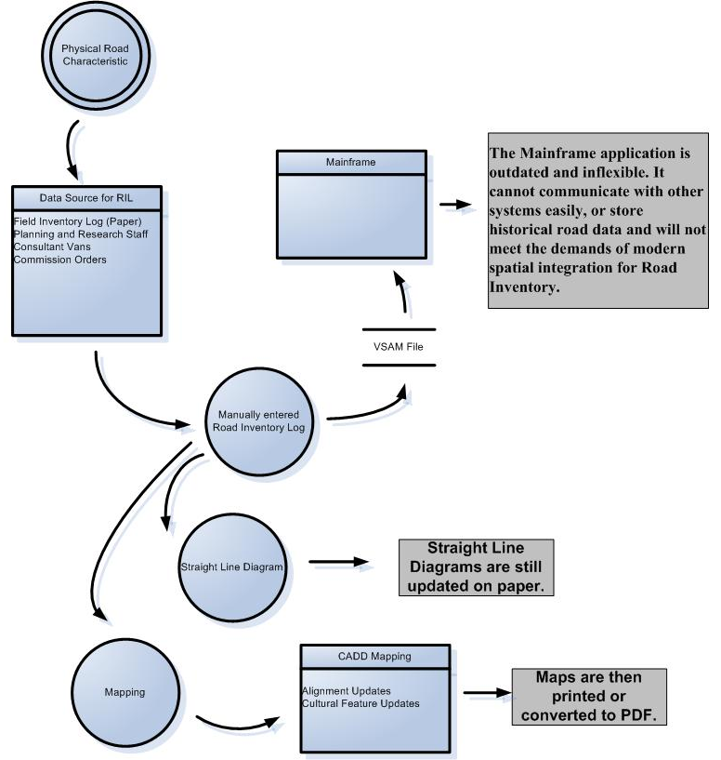
Figure 1. Road Inventory Log Process Diagram

Linear Referencing Methods
A linear referencing method is “a location referencing method in which a location is specified as occurring at some distance from a known point along a linear feature (Federal Highway Administration and GIS/Trans. Ltd 1999).” A type of LRS in West Virginia can be demonstrated by the Interstate exits; Interstate 68 exit 3, is located 3 miles from the beginning of Interstate 68. An LRM specifies locations along a linear network and there are two common methods transportation agencies adopt, base-offset (or route mile point) and reference point method. The base-offset method, also known as route mile point method where mile points are used, uses the accumulated/measured distance (or offset) from the beginning of the route/traversal. The second common method, the reference point method, utilizes a measured offset relative to a series of reference points along the route/traversal (Highway Research Board and National Academy of Engineering 1974; Federal Highway Administration and GIS/Trans. Ltd 1999; Easa, Chan, and American Society of Civil Engineers. Geographic Information Systems Committee. 2000).
State DOTs and the Federal Highway Administration (FHWA) have used the route-milelog LRM since they created the Highway Performance Systems (HPMS) in the early 1970s and, as a result, almost all state DOTs have a route-milelog LRM database (Butler 2008). The WVDOT has been using a named route-milepoint LRM since it assumed responsibility of county roads in the 1930s. It is a principal LRM and the only LRM being implemented.

RIL Improvement Project
The GTI has initiated an RIL improvement project, one of many LRS improvement projects with the goal of modernizing the technology. Because the current RIL has presented many problems, the GTI developed a new RIL based on a Relational Database Management System (RDBMS). In addition, the GTI and RTI have developed a prototype online editing and mapping solution for the WVDOT’s RIL database. The assessment of the prototype recommended additional requirements, feature upgrades and troubleshooting as well as some basic training and documentation. These issues will be addressed in the next phase.
The system will extend current roadway coverage in the RIL to all public roads and improve integration with ongoing GIS implementation efforts. It will also capture some transportation facilities such as ramps, intersections, and divided highways, currently not inventoried in the system. It will provide easier historical data tracking and a better and more flexible platform for other applications at the DOT. Figure 2 shows sample tables imported and modified to the new RIL system. The relationship between tables is established by the primary key field “rtinvID,” which is an auto incremental numeric field managed by the RDBMS.
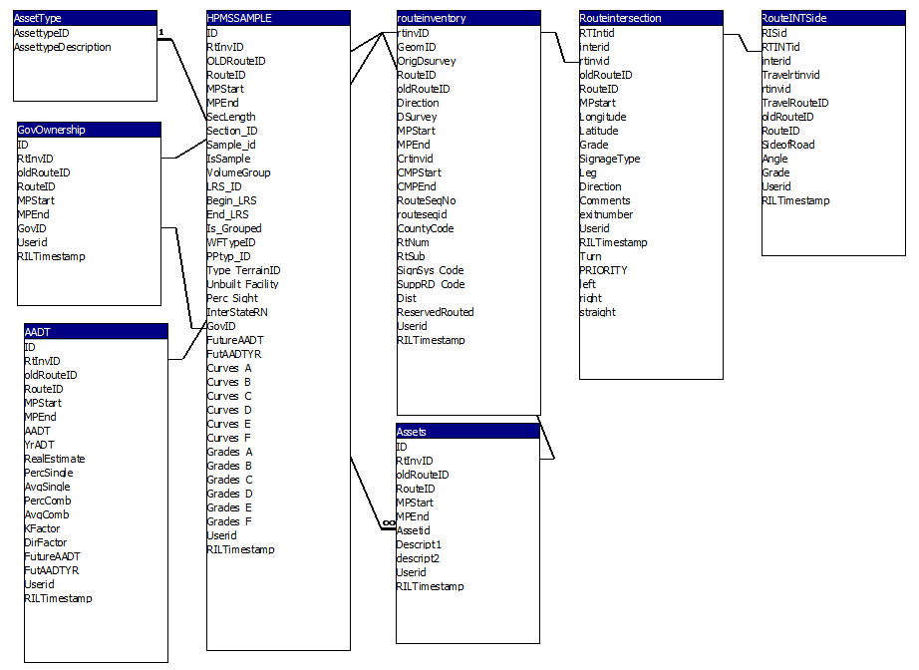 Figure 2. RDBMS RIL Tables

An improvement in the way roads are inventoried and coded needs to be made, as well. Currently, the field is written as a coded text string, that adheres to a defined schema based on character placement. Character positions 1 and 2 represent the county and character position 3 represents the sign system. Character positions 4, 5, and 6 define the route number and positions 7 and 8 would define the sub route number. Character positions 9 and 10 would make up the supplemental description of the route. The new Route ID will have a four digit route number instead of three (As shown next page) (West Virginia Department of Transportation. Planning & Research 2007).
Route ID _ _ - _ - _ _ _ - _ _ - _ _
1 2 3 4 5 6 7 8 9 10

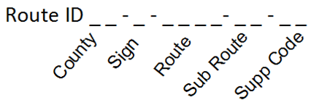
There are ongoing discussions whether the Route ID needs to be expanded further to accommodate other roadway characteristics such as the direction of travel and ramps. Any changes to the Route ID must be well thought out because many WVDOT applications and databases reference the Route ID as the main identifier of roadways. Any changes that effect the Route ID must consider all applications.

GIS Implementation at WVDOT
As mentioned before, the DOT reorganization effort established the GTI in order to continuously support GIS implementation throughout WVDOT departments and manage road networks. The GTI has developed a strategy for an enterprise GIS and Linear Referencing System that focuses on locating transportation assets and projects along transportation facilities. It was also necessary to comply with the 2010 HPMS mandate by the FHWA requiring submission of a geodatabase format file with minimum GIS network requirements (West Virginia Department of Transportation. GTI 2009).
The WVDOT uses ESRI software as the main GIS implementation software but has Microstation CAD licenses for engineering and other works. Currently the GTI has a road network (GIS base map) that covers 90% of public roadways which include Interstates, US, State, County routes, Federal Aid Non-State (FANS), State Park and Forest Roads, and other roads. Missing road coverage results mainly from FANS, State Park and Forest Roads, and other roads. The GIS unit is working diligently to fill this gap and is expected to have a complete coverage soon.
As a collaborative project, the WVDOT and RTI created a new road network from Roadware GPS data (points & lines) and digitized WVSAMB road centerlines. Routes were manually created without segmentation. Opposite direction traversal was added to Interstate and US highways whether or not it is a divided highway. Beginning and ending distance measures of a segment (based on RIL and SLD) were entered to populate M-values for every vertex of a route, which allows dynamic segmentation. The entire road network has not been calibrated to reflect elevation. The WVDOT uses a dynamic segmentation technique to query a database, display/map data, and determine linear measure (only for reference purposes). The RIL, SLDs, and aerial imagery were used for additional quality control, alignment calibration, and attribute population. The final overall scale of the GIS base map is 1:4,800.

Linear Referencing and GIS
Linear referencing provides a set of methods and procedures for recording and retrieving locations along linear networks, and a typical LRS contains a transportation network and a location reference method (Miller and Shaw 2001). Emerging technologies and data collection methods have changed the way linear referencing is viewed and implemented. The NCHRP Report 359, “Adaptation of Geographic Information Systems for Transportation,” provides an overview of the adaptation of GIS for the management and integration of the transportation information, and recommends that transportation agencies develop a conceptual organizing principle founded upon the notion of location as a data integrator (Vonderohe et al. 1993).
The implementation of linear referencing in GIS among transportation agencies has become standard practice and, as a result development of a complete Transportation GIS Linear Referencing Data Model is imperative. A data model will illustrate the digital representation of transportation systems and the complex relationships among its components.
Previous efforts have produced a number of linear referencing data models that attempt to improve on the traditional tabular network database by applying a more sophisticated network data model that incorporates spatial elements (Krätzschmar 2001). In practice the same problems commonly experienced with linear referencing have to be addressed (Federal Highway Administration and GIS/Trans. Ltd 1999). These are:
- the integration, translation, and transformation of data based on different linear and location referencing methods
- the effect of updates to the road networks on linear referenced data sets due to realignment, re-measurement, new construction, etc
- the limitation (accuracy) of one-dimensional measurements as applied to the real-world measurement.
The model must also be able to support legacy systems (or at a minimum, transition to the new system), future enhancements, and database maintenance.

Enterprise LRS Data Model

4.1.1 NCHRP 20-27 (2) LRS Data Model
The National Cooperative Highway Research Program sponsored the NCHRP 20-27 (2) LRS data model in response to the needs of the transportation community for such a product. The data model was primarily based on the results of a workshop held in Milwaukee, Wisconsin, with the objective of developing a draft consensus conceptual data model for a linear referencing system. Workshop participants recognized that the development of a single data model that would meet the needs of all application areas was difficult and sought a generic model that met common needs and formed a core that could be extended in specific application areas. The model supports the following fundamental operations (Vonderohe et al. 1997):
- Locate. Establishment of the location of an unknown point in the field by reference to objects in the “real world.”
- Position. Translation of a real-world location into a database location.
- Place. Translation of a database location into a real-world location (the inverse of the “position” operation).
- Transform. Conversion between various linear referencing methods, represented by database locations; between various cartographic representations; and between methods and cartographic representations.
The model supports higher-level operations associated with GIS such as overlay and topology as well as those associated with network analysis, such as pathfinding, routing, location, and allocation..
Figure 3 depicts a conceptual overview of the data model. The model includes three primary components: 1) linear referencing system; 2) business data; and 3) cartographic representation. The linear referencing system includes linear referencing methods, networks, and a datum. The data model uses a single linear datum that supports multiple cartographic representations at any scale and multiple network models for various application areas. The linear datum provides the fundamental referencing space for transformations between different linear referencing methods, multiple network models, and cartographic representations at various scales. The linear datum is comprised of anchor points and anchor sections. Anchor points represent well known, uniquely identifiable real world locations, such as the intersections of two streets. Anchor sections connect two anchor points and represent the roadway segment. Business data refers to event data and is tied to traversals (or routes), which are built upon network links, through LRM.

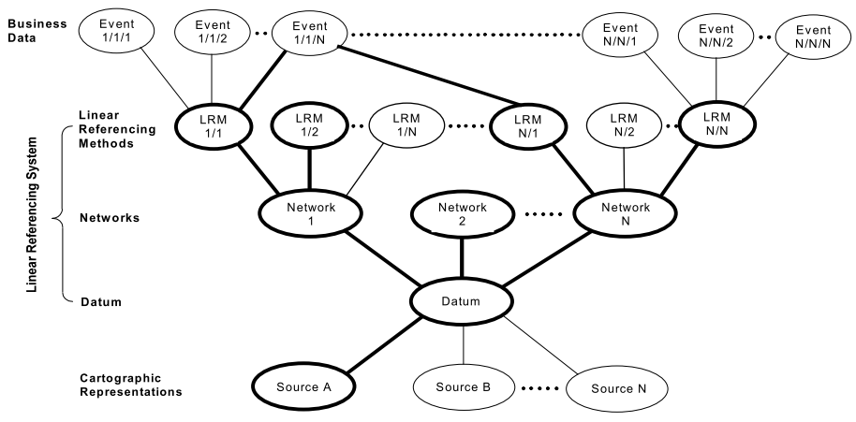
Figure 3. NCHRP 20-27 (2) LRS data model conceptual overview
A data model was developed in the format of an entity-relationship (ER) diagram, which describes the key elements of the linear LRS and the relationships between them. Figure 4 shows the ER diagram of LRS data model.
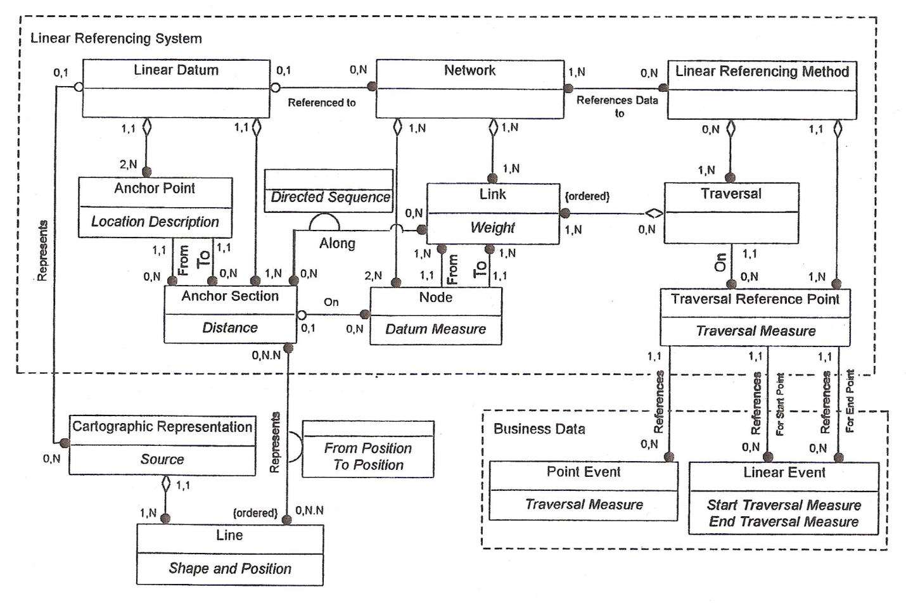
Figure 4. NCHRP 20-27 (2) LRS Data Model Entity-Relationship Diagram

4.1.2 The Dueker-Butler Model (GIS-T Enterprise Model)
Dueker and Butler developed a GIS-T enterprise data model that incorporates linear and non-linear location referencing systems. Similar to the NCHRP 20-27 (2) LRS data model, the Dueker-Butler model is independent of: (1) geographic datum; (2) the events that occur on the transportation system; (3) the geometry that represents the system; and (4) the link-node topology that makes up transportation systems. The model also supports areal transportation features (e.g., airports, railyards) as well as areal events (e.g., park-and-ride lot). Area events can be a non-transportation feature that affects transportation features (e.g., intersect). Figure 5 shows the conceptual data model in Entity-Relationship format.
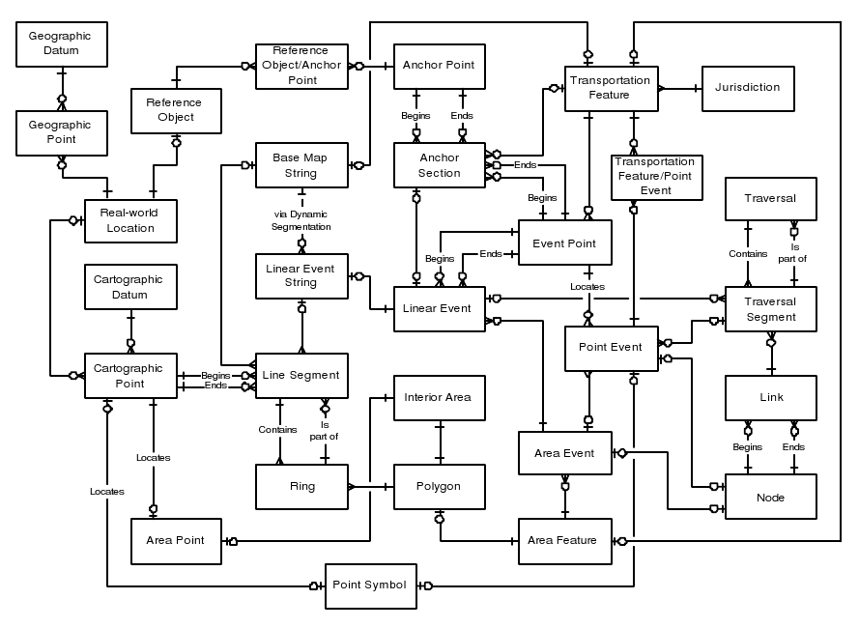
Figure 5. Dueker/Butler enterprise LRS data model
The most basic entities of the model are transportation feature, jurisdiction, and events. A transportation feature is an identifiable element of the transportation system and can be either a point, a line, or an area. Jurisdiction is a political or other context for designating transportation features. An event is an attribute (e.g., functional class, speed limit, pavement type), occurrence (e.g., traffic crashes, projects), or physical component (e.g., guardrails, signs, bridges) of a transportation feature (Dueker and Butler 1997).

4.1.3 UNETRANS
With funding support from ESRI, University of California at Santa Barbara developed the Unified Network for Transportation (UNETRANS) data model in consultation with a consortium of users from transportation communities (Butler 2008; Curtin et al. 2003; Krätzschmar 2001). The consortium focused on the needs of organizations that manage road and rail networks and intended to simplify enterprise project implementation, encourage data sharing with consistent data structure and provide a common starting point for application developers (Curtin et al. 2003). The objective of the UNETRANS project was to develop essential objects needed for the most common transportation applications (Krätzschmar 2001). Figure 6 shows an analysis diagram - a layout of all data objects (features and tables) that comprise the model.

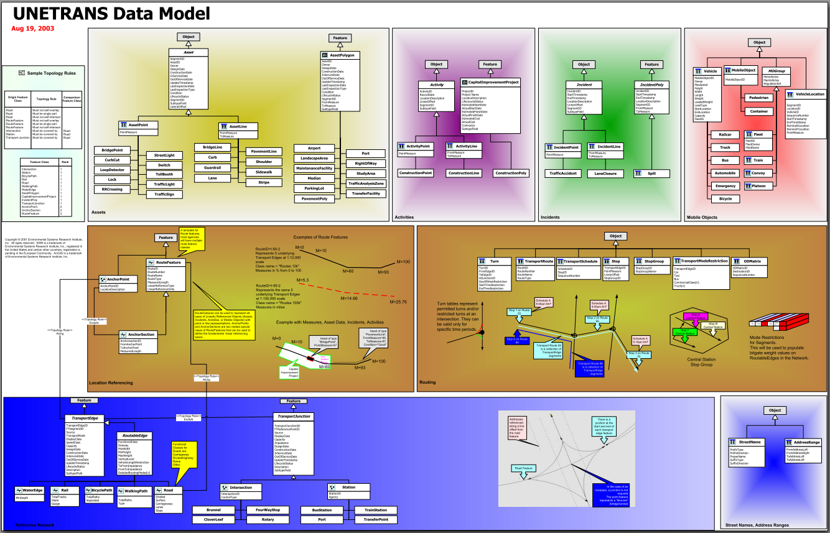
Figure 6. UNETRANS Analysis Diagram

Relationships are specified with connections between objects specified with a name, attributes, and behaviors. The UNETRANS model uses the ArcGIS geometric network as the underlying structure and every feature class or table inherits properties from one of the core ArcGIS object classes (Feature, Object, ComplexEdgeFeature, SimpleJunctionFeature) (Butler 2008; Curtin et al. 2003).
The UNETRANS model is subdivided into six packages (or logical groups) of related features and object classes, and a package of objects may be related by function or type (Curtin et al. 2003). Figure 7 is an overview of these packages:
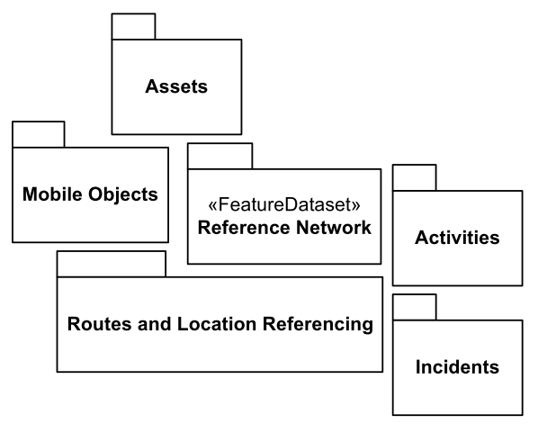
Figure 7. UNETRANS Packages
- Reference Network - A representation of linear facilities in a transportation system (e.g., road, railroad tracks, bike paths, navigable waterways). The topological network defines the connectivity and adjacency of links.
- Routing and Location Referencing - feature and object classes to support turns, routes, mode restrictions, and other essential aspects of transportation network operations as well as procedures to reference objects to the transportation network.
- Assets - Representation of physical features that are not part of the network but are related to the network.
- Activities - Representation of planned actions that are related to the underlying network but are not elements of the network itself.
- Incidents - Representation of termed occurrences (e.g., traffic accidents, citations, spills) that are referenced to the network
- Mobile Objects – Representation of objects (e.g., pedestrians, airplanes, automobiles, bicycles) that can be transported across the network.
The UNETRANS model was never completed, but it introduced a design aspect combining the linear datum, geometry, and network connectivity into a single geometric network (Butler 2008).

4.1.4 Improved UNETRANS
Butler (2008) stated that the evolution of ArcGIS technology and experience with UNETRANS led to the improvement and enhancement of the original model. He proposed to regroup the original class packages into fewer packages structured by the application area. The original six packages with relationship classes are aggregated to four packages: Inventory, Network, Events, and Users (Mobile Objects). Figure 8 shows these regrouped packages. The Inventory package includes support for all types of transportation facilities including their characteristics and elements. The Network package utilizes new transportation-specific network model and replaces the geometric network. The Event package combines the previous Activities and Incident packages into a package representing things that occur on and to transport facilities. The Mobile Object package is an expanded version of the original package involving users of the transport system.
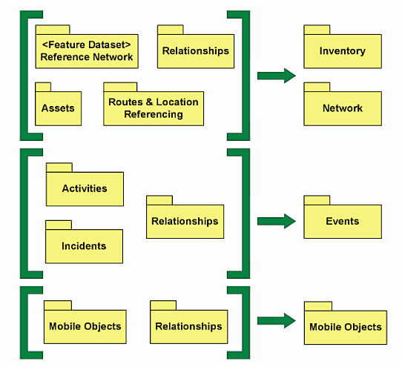
Figure 8. Revised Class Packages
The Entity class template, an abstract superlcass stereotype, is for developing all tables and feature classes to provide temporal support and editing process management by adding a set of standard fields to all user-defined geodatabase classes. The model promotes separation of the position data from the other entity attributes, and makes it possible to accommodate multiple datums for both linear referencing and geographic position. Figure 9 shows the Revised UNETRANS Inventory package, and its primary object classes which support facilities, their descriptive aspects and component elements, LRM position, and geographic coordinates. The new model adopted recent geodatabase design methods, separating route events into element (facility components, physical presence), aspect (facility attributes, descriptive facility characteristic), and things that happen (real events).
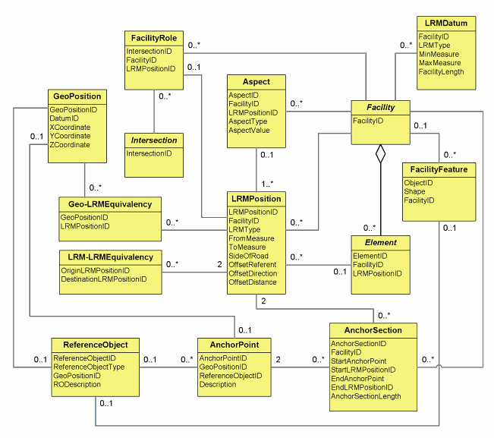
Figure 9. Improved UNETRANS Inventory Logical Model

Linear Referencing Implementation Issues
It is very important to consider the rules and processes included in the model as they relate to business needs. Depending on the transportation agency’s business requirements, a model can be implemented in many different ways. From several meetings and interviews with GTI staff, several linear referencing issues were identified. A slightly modified FHWA and GIS/Trans. Ltd (1999) questionnaire was used for interviews to review linear referencing and GIS practices in the GTI. The questionnaire and results can be found in the Appendix C. The official management manual for linear referencing is not currently available (lost or misplaced over time) to GTI staff and it is absolutely crucial to establish the linear referencing rules/policies and procedures. LRS documents (SHL and Mississippi Dept. of Transportation 1996; Wisconsin Dept. of Transportation 1997; Vogt, South Dakota. Dept. of Transportation. Office of Research, and Re Spec Inc 1997) are available from other State DOTs and can be used as references. Some of the identified issues are:
- Coding traversal (route) identifier
- Use of separate traversals for each travel direction
- Special cases for defining traversals (divided highways, ramps, overlapping traversals, realignment, etc.)
- Location accuracy
- Linear referencing for local roads
- Determining location and distance (data collection methods): field and office practices
- LRS maintenance and quality control
- Management of historical data
- Multimodal integration

Preliminary/Pilot LRS Data Model for WVDOT
The following model is based on the Improved UNETRANS LRS data model. It is not the intent of this report to design a detailed and fully functional linear referencing system data model for the WVDOT RIL. Rather, this research was to determine the feasibility of developing a data model that can accommodate a single, statewide road centerline dataset. This research and report should be used as a reference in conjunction with the WV DOT business needs analysis to develop a refined data model. It is highly recommended that additional research be pursued to develop a full scale pilot to guide the data model creation before a statewide production version is implemented.

Road Inventory Log Logical Model
Butler (2008) offered a general logical data model for a state DOT facility inventory. Figure 10 shows a highway inventory logical data model. This model is based on Figure 9 and adopts the “everything is an event” view commonly implemented in state DOTs. The model can be modified and used to build a new RIL data model. The Event class on the model represents elements, aspects, and occurrences as events that happen on a roadway at a point event or linear event. Other classes represent elements (e.g., tunnel, culvert, bridge, sign assembly, pavement segment, intersection) located on a roadway using Event as an associative entity to connect the elements to LRM and geographic positions.
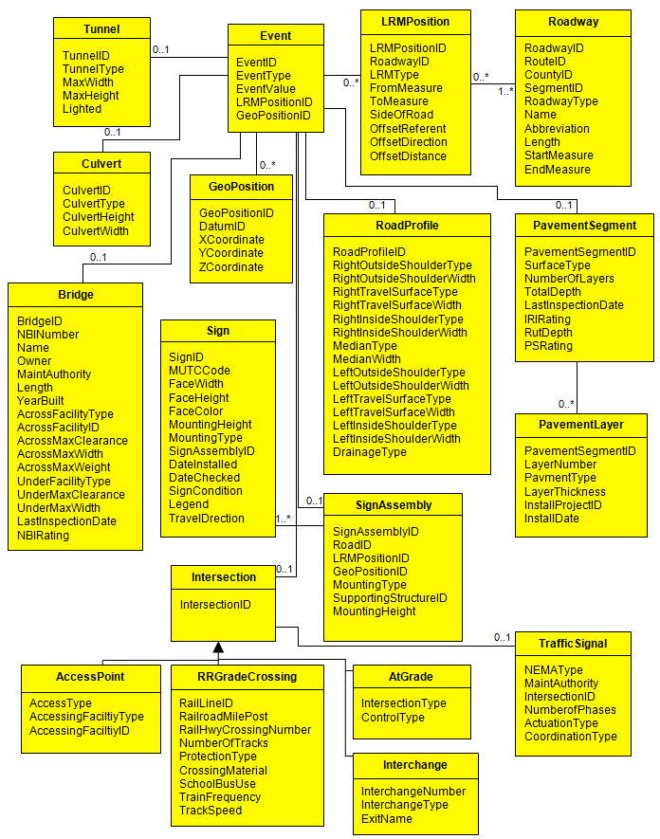
Figure 10. Highway Inventory Conceptual Data Model

Route Segmentation
As discussed previously, the WVDOT has used a route-based LRM with routes extending from state line to state line. Routes are typically composed of multiple segments. Initially each segment may represent the extent of a highway within a given county or district (sometimes state), but realignment and other changes will increase the number of segments. The Improved UNETRANS model supplies the standard class templates with domains for a route segment and is shown in Figure 11. Implementing the Entity template (e.g., RecordDate, RecordStatus, EntityStatus, FromDate, ToDate) in these tables with domains (EntityCodes and RecordCodes) enables attribute level edit management and history recovery.
The template route table contains RouteID (identifier of route, e.g., four digit route number), Name (route name, e.g., US 60), Abbreviation (route abbreviation for labeling), and RouteType (different highways or sign system). The segment table contains CountyID, SegmentID, RoadwayID, and RCLink. CountyID is a three-digit FIPS code for the county. RoadwayID is a computer-generated simple candidate primary key and is used as a foreign key for relating to event classes and to link to geometric representations (e.g., centerline feature class). RCLink is a character string composed of RouteID, CountyID, and SegmentID and is a public key to relate roadway characteristic events to routes. These can be replaced and modified to use WVDOT codes for the RIL file. Figure 11 also shows how the Segment table is related to the Centerline feature class. The new UNETRANS model supports separation of the position data from the other attributes in order to accommodate multiple datums for both LRM and geographic positions. The Segment template in the figure uses a single LRM with included from- and to- measure values. Using the LRMPosition table instead of measure values in the Segment table can support multiple LRM types and is shown in Figure 12. The relationship cardinality between a segment and a centerline is one-to-one, and one centerline should exist for each segment. Multiple versions of a segment and a centerline can exist, but there is only one active status of each. This is possible because of Entity edit and temporal management.
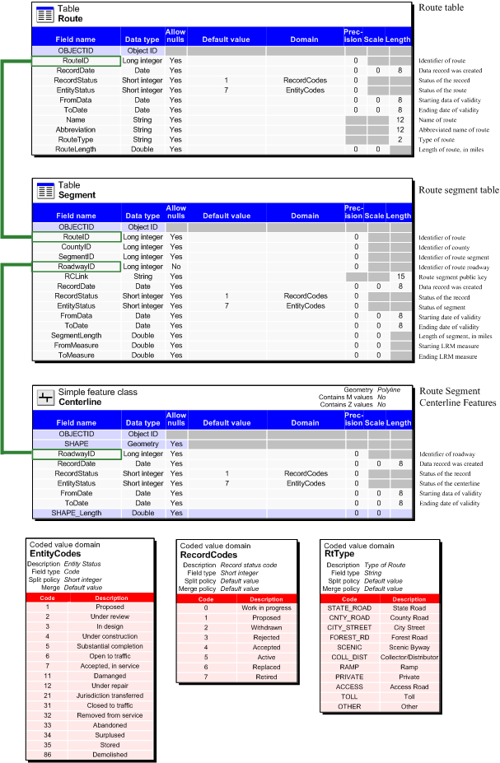
Figure 11. Route Segmentation
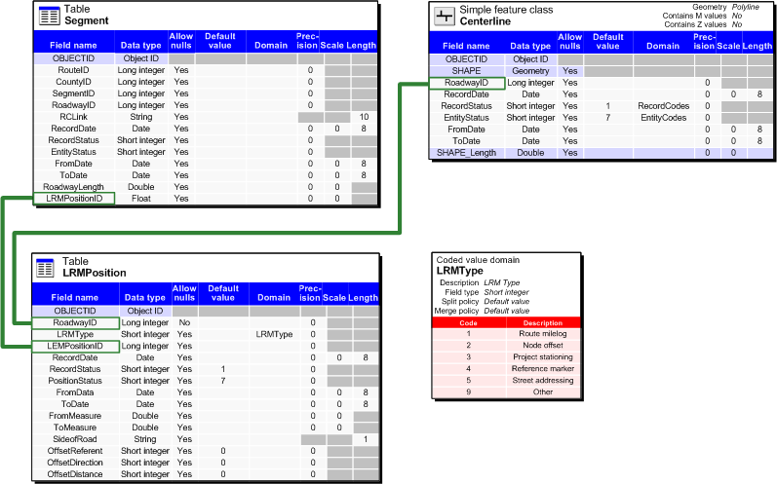
Figure 12. Alternate Segment Table Design

Events
Adopting the “everything is an event” view, Figure 13 shows the geodatabase design of the Event and Inventory packages. In this design, the location data is moved from the Segment table to the LRMPosition table in order to support multiple LRM types (e.g., route-mile and street addressing). The Event table also uses a LRMPosition table plus a GeoPosition table to provide a location reference in lieu of its own location attributes. When the event represents a transportation facility element (in this case an interchange which is one of four intersection subtypes; at grade intersection, access point, Railroad crossing, and interchange), the EventType table provides more descriptive information. The event type of “Intersection” indicates that EventValue field in the EventType table stores the identifier (IntersectionID) of the interchange which is a foreign key pointer to the Intersection (Interchange) table. The ElementClass field also points to the Intersection (Interchange) table that contains that matching foreign key value. The Intersection feature class and table stores routable information (e.g., direction of travel, turning movement, etc) that is needed to create a navigable road network.

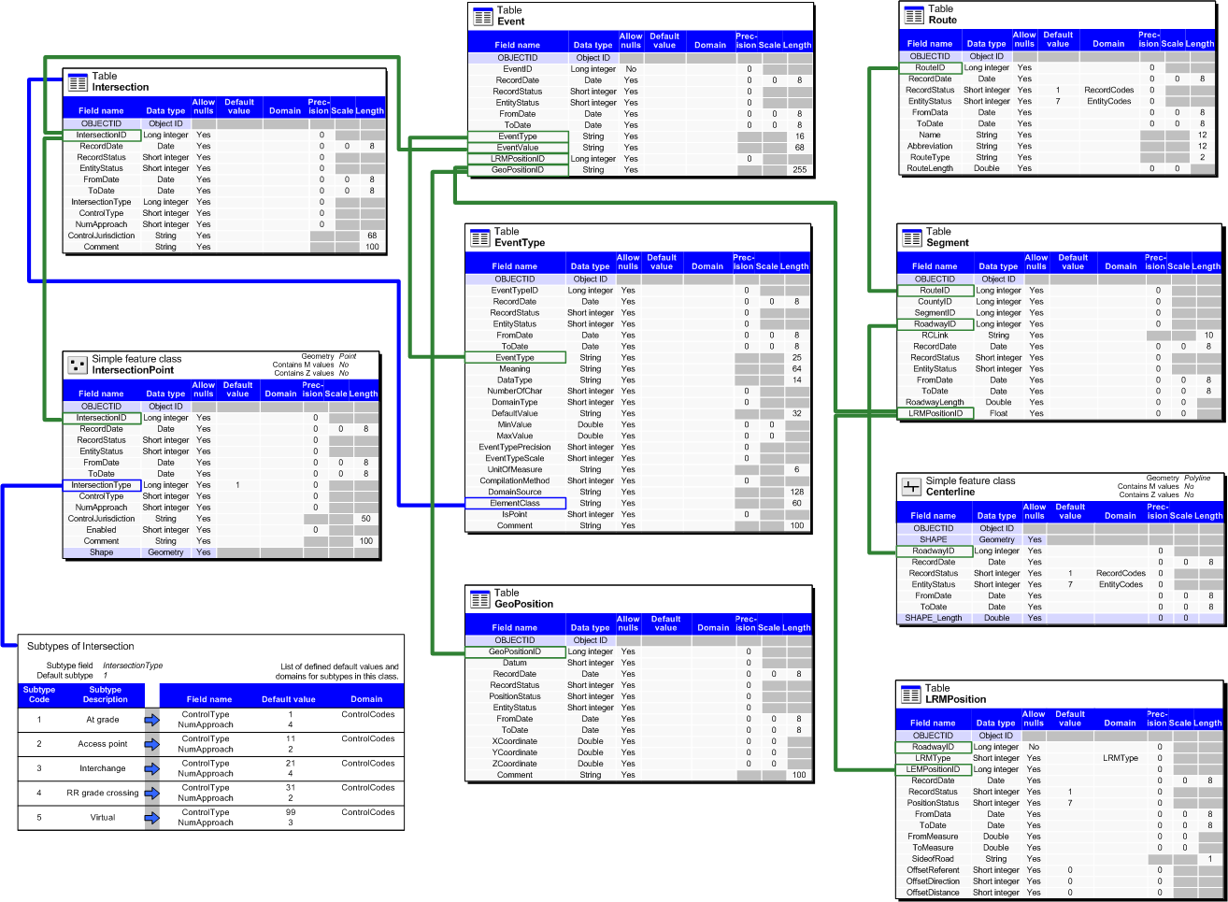
Figure 13. Event and Inventory Package geodatabase design

Navigable Network
The improved UNETRANS replaces the geometric network with the transportation specific network dataset and continues to support pathfinding (routing/traversing) applications. Network datasets are composed of two basic (edges and junctions) and one optional (turns) network elements (Environmental Systems Research Institute 1999). Edges connect junctions where flows travel. Junctions connect edges and where flows can move from one edge to another edge. Turn elements store turn movements/restrictions and cost impedances. In addition, elements have attributes that supplement flows along the network. For example, edges may have movement restrictions (such as one-way information) and impedances (such as traversal time), turn elements may have movement restrictions (such as no left turn) or impedance measures (such as average time in intersection).
Elements are generated and connectivity is established from the source features when the network dataset is created. The new network dataset can be created from a shape file or feature classes within a feature dataset. The only required source data is a feature class that provides edge features (such as the road centerline). If a junction source is not provided, the process will create junction features where lines terminate and where two lines cross.
WVDOT and SAMB data does not include attribute information on turn restrictions or one-way roads. However, certain attributes contained in the RIL can be used to generate networking attributes, For example, speed limits can be used to generate travel times or weight classes can be used for barrier restrictions. Building and maintaining a comprehensive statewide set of attributes that are required to support advanced routing would be challenging and time consuming, but it could be accomplished through several phases over time. An alternative such as commercial routing is readily available for use from private sector entities such as Navteq or TeleAtlas. In addition, networking attributes are available for purchase or lease, but typical license agreements are restrictive in use and/or prohibitive of data sharing. There could also be data conflation issue between a commercial network dataset and WVDOT data.

Publishing Data
Butler (2008) recommends using two separate geodatabases for editing and publishing. An effective editing geodatabase is designed to support editing routines and is highly normalized. Such a geodatabase is not suitable for data analysis and applications that require denormalized and derived data. Significant performance improvements can also be achieved by separating an editing database from publically distributed data. The edit geodatabase would support the published geodatabase by extraction and joining routines (manual or automated) that harvest normalized data to produce denormalized tables and feature classes. The published geodatabase will not reflect the same data structure as the editing geodatabase. For example, individual tables in the edit geodatabase may be appended in the published database, or a highly segmented centerline may be linear-referenced.
Figure 14 illustrates the short process required to publish a centerline feature class for dynamic segmentation. Shown are the relationship steps, sample tables, and the resulting feature class. The Route, Segment, and LRMPosition tables are joined using foreign keys (RouteNumber and RoadwayID in this example) which adds route information and LRM locations to the Segment table. The Segment table with added information is joined to the Centerline feature class. This step provides centerline features with route identifier and measurement values which are required to create the route feature classes. Using the Create Route function in ArcGIS Linear Referencing Tools, the output Centerline feature class will have M-values. Optionally, calibration points such as anchor points, if available, can be used to increase accuracy of the route. Similar to the Centerline feature class process, the process of publishing a denormalized Event table is shown in Figure 15. The Event, LRMPosition and GeoPosition tables are joined to create the output Event table with LRM and Geographic locations data. Then extract and combine each event type by group and combination. Different Edit geodatabase designs will have different publishing processes.

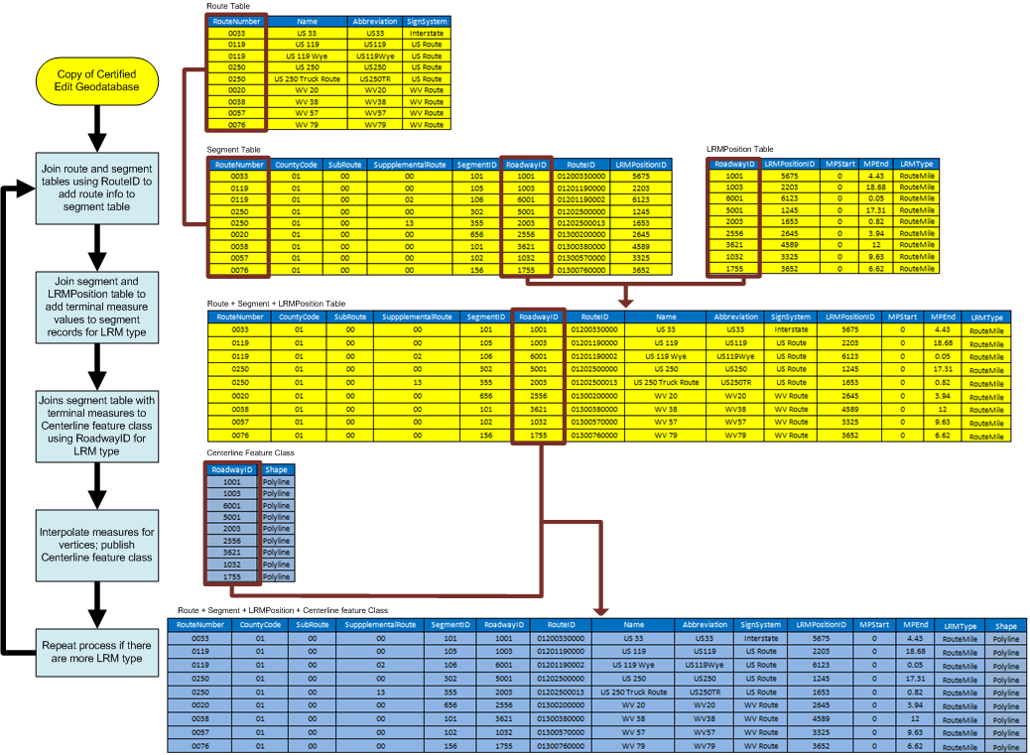
Figure 14. Publishing Centerline Feature Class

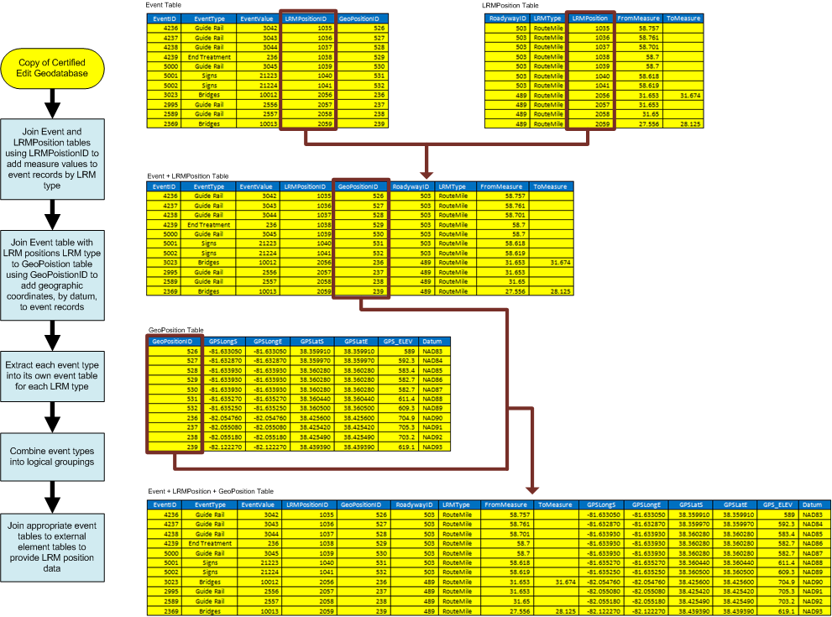
Figure 15. Publishing Event Table

7. Statewide Addressing and Mapping (SAM) Data
The SAM system was created to support a comprehensive addressable point location and street dataset, developed as part of a statewide re-addressing project. The data is housed at the WV Dept of Military Affairs and Public Safety in an Oracle Spatial database. Road geometry for the entire state was provided to the counties for attribution and addressing. The geometry and attribute data is maintained on an individual county basis and is dynamically updated. Counties are responsible for completion of the addressing component of the SAM project. All counties have assigned users of an online web portal for SAM data access. Both editing and updating tasks can be performed online, however, not all counties actively participate in the SAM system. Participating counties maintain their addressing data using ESRI software, through third-party contractors or other in-house software. The majority of WV counties are active participants in the SAM system, though none are currently required to participate. This results in incomplete and inconsistently updated data on the SAM system. Though data on the SAM system can be evaluated for currency, no active tracking system exists for counties who maintain their data offline.

7.1 Geometry
Road centerline feature geometry was initially digitized from leaf-off, natural color, 2' resolution aerial photography (flown in 2003-2004) as part of the SAM planimetric data collection. The features have a scale of 1:4,800. Though the SAM data was originally provided as a seamless statewide feature class, the SAM road geometry is divided into individual counties in the Oracle database. This was done to allow individual counties easy access to their own data and to allow continuity of roads that meander across county lines. Additional or updated road geometry may have been added by individual counties at any time, utilizing a variety of sources. Roadways were collected as centerline line features, regardless of number of lanes. Divided roads, such as interstates and boulevards were collected as two independent centerlines representing each direction of travel. All roads visible in the 2003 SAM aerial photography were collected.
SAM road geometry was initially topologically enforced and should maintain a high level of topology. Physical road intersections were represented by segmented lines, bridges and overpasses were not joined and features are continuous. This type of topology is required for the creation of navigable networks. Topology is no longer enforced, and would need to be reviewed and verified before it could be used for networking purposes. Specifically, a major area of concern rests between county lines, where duplicate and overlapping features exist. Edge-matching and cleaning these features would need to be accomplished before this geometry would be suitable for use as a WVDOT edit centerline feature class.

7.2 Attributes
SAM attribute information is stored in the road centerline geometry and in additional tables within the Oracle database. Attribute information is associated with each line segment feature and linked by a unique street identifier (Street_ID). The Street_ID is unique to each street segment across the entire dataset and is automatically assigned by the Oracle database upon creation of the road segment. The initial SAM project collected all roads; both public and private, including driveways and un-improved roads and trails. The roads are classified using the "Street_Type" field. This is a coded value which includes classifications such as 'Interstates, Proposed, Driveways, Ramps. etc.'. Features were reviewed and found to generally match the appropriate classification, though all features may need to be reviewed or verified systematically for WVDOT usage. In addition to the Street_ID and Street_Type, there are multiple other fields that are identified in the WV SAMS Data Specification (Michael Baker Jr., 2007), including addressing information. (Again, the county is responsible for completion and updating of the addressing information, not all counties have completed addressing information.) Most of the addressing information is stored directly as attribute data, contained within several fields in the attribute table such as: left/right, from/to address range and address number. Additional attributes such as the Street Name, Post_ID (city) and County_ID are coded values that reference additional tables, such as the actual street or city name. Using coded values that relate to stand alone information tables has both advantages and dis-advantages. One advantage is that the WVDOT and SAM may be able to consolidate or share particular tables. Database replication will most likely be necessary to efficiently access or maintain a single table. This is an area for further research.

8. Edit Centerline Feature Class
The Improved UNETRANS data model will ultimately support feature classes for editing and publishing. The edit geodatabase should have a single feature class that represents a comprehensive road network geometry for all transportation facilities. For sake of clarity, we refer to the centerline feature class in the edit geodatabase as the 'edit centerline feature class'. The edit centerline feature class is derived directly from the SAM centerline data and will have minimum attributes, which includes the SAM 'StreetID'. The StreetID is used to relate to all other attribute and tabular data from SAM and/or WVDOT such as the segmentation table. Currently, the WVDOT does not have a single feature class that can serve as a suitable edit centerline feature class; WVDOT data sources are lacking both proper geometry structure and attributes. The WVDOT 'All Routes' dataset currently does not incorporate all roads, or addressing information that would be needed for an addressable dataset, or geocoding services. The existing WVDOT data is not suitable for navigable networks and topological issues are present.
The existing SAM data cannot currently fulfill the role as an edit centerline feature class either. SAM data is lacking WVDOT identification and has significant topological issues. The edit centerline feature class must be created; using a combination of SAM and WVDOT data, with appropriate centerline geometry, topology and attribute information according to the WVDOT Improved UNETRANS data model. The new edit centerline feature class will not only need to meet the new WVDOT data model, but be able to integrate seamlessly with the existing, or slightly modified SAM data structure.
There are multiple approaches to create the edit centerline feature class. SAM data could be selectively extracted and then integrated with the existing WVDOT data to create a comprehensive road dataset. This approach could preserve any data and edits that have been made by WVDOT, but may still require significant editing, such as topological enforcement. This approach would also necessitate the need to conflate any needed addressing data from the SAM to the existing WVDOT data where necessary. The edit centerline feature class could be a mix of existing WVDOT route data, such as WVDOT interstates and US Routes, and SAM roads for the remainder. There are several disadvantages to this approach. First, it would be more difficult to use as a bidirectional database system (discussed in the next section). Secondly, any geometry carried over from the WVDOT would lack addressing information, which would require attribute population or creation of a dynamic segmentation table of address ranges. Finally, existing segmentation of the WVDOT may not match the proposed data model, requiring roads to be segmented and attributes edited to reflect the new segmentation. Alternatively, a favored approach would be for the WVDOT to adopt and integrate the entire SAM road centerline data. This would allow for a consistent base that would pose limited problems for bidirectional integration. The SAM data geometry may be a better candidate due to its existing segmentation and addressing attributes. This could reduce topology edits for some areas, however, significant topology edits would still need to be performed at county boundaries. The disadvantage to this approach is the complete re-generation of the LRS. The existing LRS could be used in the interim, and also be used as the template for creating a new SAM based LRS. The approach of creating the edit centerline feature class may best be resolved once the WVDOT data model is specified and the data sharing policies are determined. This will help refine the amount of work the chosen integration approach would involve.

9. SAM Data Accessibility
There are several approaches that WVDOT could use in order to integrate the SAM data. A simple, one time integration of data could be performed with data harvested directly from the SAM system. This would be the easiest method to use in order to gain all road geometry, however, the addressing attribute information and data currency would be incomplete. Multiple data harvests could be performed on an individual county basis, but data currency would again, be an issue. The alternative approach is to develop and establish a long-term bi-directional relationship between WVDOT and SAM in order to create a unified road dataset that can accommodate each agencies’ needs well into the future.

9.1 Harvesting SAM Data (non integration)
The WVDOT could readily harvest (access and download) SAM data for its own use with little or no impact upon the SAM system or individual counties. A single data harvest could be used by the WVDOT to create its edit centerline feature class, which is not tied to the SAM system. This would reduce the complexities between WVDOT and SAM, and allow for simpler implementation policies rather than an integrated, bidirectional approach.
It is also possible for the WVDOT to utilize the SAM system to directly perform some edits to the SAM data online. However, edits made by the WVDOT would be restricted to a limited, pre-determined set of edits which SAM and the counties would approve. (For example, the WVDOT could add new road geometry, which could then be addressed and attributed by the local county.) In addition, the data would still not meet the WVDOT data model and would require additional attributes and further editing. Off-line editing may be a preferred alternative by WVDOT, as is currently being done by several counties. However, if a county uses an offline workflow, it could pose problems for WVDOT data harvesting, where the latest data is not available on the SAM system. Simply harvesting SAM data for WVDOT usage poses many problems that may not create an efficient centerline dataset.

9.2 Data Exchange and Integration
The SAM data is constantly being updated by individual counties and is therefore in varying stages of completion. It would be difficult for WVDOT to build a complete statewide or even district-wide dataset using SAM data due to the sporadic nature of edits and a lack of completed or current road geometry and attributes. In addition, data harvested from SAM would need to undergo edits, such as inter-county edge matching, in order to fulfill the role as an edit centerline feature class. These edits could be performed by WVDOT on data harvested from SAM, but would prohibit further harvesting in the same area without repeating or additional, continual editing. Data would need to be re-harvested in order to gain updates made by the counties; otherwise, WVDOT would be completely responsible for any additional updates in geometry or attributes. In addition, if the WVDOT simply harvests data, the SAM and counties would receive little or no benefit for WVDOT data access. Whereas shared data that is edited by WVDOT and integrated back into the SAM system would avoid duplication of effort and benefit the SAM system and counties. These factors present a strong case for more than simple data harvesting and make a case for the need for a bi-directional relationship between WVDOT and SAM. Development of a data sharing policy that could support an integrated road dataset, shared between the WVDOT and SAM is strongly encouraged.
A primary reason for data sharing would be to provide the WVDOT with a mechanism to integrate data it has edited and revised, back into the SAM system. This would not only benefit the SAM and counties, but would also benefit WVDOT. By integrating edits performed by WVDOT, those edits are perpetuated in future data access by all parties. It is important to maintain corrections and changes to the data once edits have been made by either WVDOT, SAM or the counties. Though a bidirectional approach is preferred, concurrent editing operations can be highly complex. Coordination may be needed between WVDOT and the counties to prevent data currency and concurrent editing problems. An additional level of complexity is the cross platform data structure. WVDOT uses an ESRI ArcSDE enterprise geodatabase while the SAM system uses Oracle Spatial, though it should be noted that ESRI and Oracle have a high level of interoperability. This would require further research which would work through data sharing policies between parties and explore the technical capabilities of the existing SAM system. Additional research is recommended to resolve the new WVDOT data model, any SAM data structure changes and the technical interchange of data sharing.

9.3 WVDOT and SAM Data Link
In order for the WVDOT to utilize the SAM data, it must establish a relationship between the SAM centerline geometry and existing WVDOT data. The existing SAM centerline attribute 'Street_ID' can serve as the RoadwayID (as found in the Improved UNETRANS data model). The Street_ID is a unique identifier found on each line segment in the SAM data which is automatically assigned by the Oracle database. The WVDOT can then create a Segment_ID which relates one-to-one to the RoadwayID (Street_ID). This relationship is established in the segment table and allows separate SAM and WVDOT operations in two separate, but parallel, databases.

10. Integrated Road Network Pilot
One component of this research project was to develop a small pilot that would test integration concepts with actual data. The goal of the pilot was to identify the feasibility of using the SAM road centerline data for WVDOT purposes. The study involved identifying and comparing road geometry and attribute information between WVDOT data and SAM data. The SAM data was studied to see if it could be used to support the creation of the edit centerline feature class found in the Improved UNETRANS data model. The study area used for this pilot was Kanawha County, which was chosen because it provided a good mix of transportation facilities and has a relatively high level of completed addressing data. The study utilized data downloaded from the SAM Oracle database and data provided by WVDOT. The pilot did not fully create the data model with an edit and published geodatabase, with all tables and relationships. Rather, the intent was to verify if the SAM data could support the creation of the edit centerline feature class. The pilot produced a working sample of the SAM data as use of a edit centerline feature class that supports the three WVDOT objectives of integration; linear referencing, addressing and navigable network capabilities.
It should be noted that all functions described in this pilot utilized ESRI ArcGIS Desktop 9.3.1 and 9.4 Beta products, including ArcMap at the ArcInfo license level, the Linear Referencing Toolset and the Network Analyst extensions.

10.1 Technical Conflation
The approach used to create the pilot edit centerline feature class was to add a new field in the Kanawha-SAM data that contains the WVDOT Route_ID. In the data model, this step replaced the function of the segment table, in that the StreetID could be used to relate out to the additional WVDOT tables. This process was done manually by selecting individual line segments along a route and assigning the appropriate Route_ID, using the existing WVDOT route data as a template. By adding the Route_ID to the SAM data, the edit centerline feature class could be used to build a network dataset and be used to generate a route feature class with measure-values (a linear referenced feature class). These two new feature classes were then tested for functionality. This approach was chosen for its simplicity in allowing assignment of a single new attribute to relate the existing WVDOT data.
An alternative approach would have been to create the segment table that cross links the Street_ID to the Segment_ID, which would have been assigned by the WVDOT. This was not necessary for this set of testing purposes. These two approaches to conflation are some of many potential methods of building a relationship between the WVDOT and SAM datasets. The final method would be determined by the WVDOT data model and requirements of the SAM system, while accounting for efficiency in processing the data. This is an area for further research.

10.2 Route Feature Class
Routes were generated by using the linear reference toolset, utilizing the attributed Route_ID assigned in the previous section. Though the Route_ID was used as the key to create the route, this step would apply to any process used to publish data, as described in Section 6. The LRM feature class was created, but was not calibrated. Again, once the routes are built, they could be calibrated utilizing measurements from the SLDs. To test the functionality of the LRM, bridges from the RIL database were created as events in ArcMap, utilizing beginning and ending milepost attribute data. Though testing resulted in an approximate bridge placement (Figure 16), they were found to be out of position by a consistent error, indicating the need for route calibration. The final WVDOT data model and LRS procedure rules would determine what corrections could be made, and that would account for errors in utilizing the SAM data. (For example, line geometry from SAM was collected from aerial photography, and may not match the line geometry collected by Roadware. )
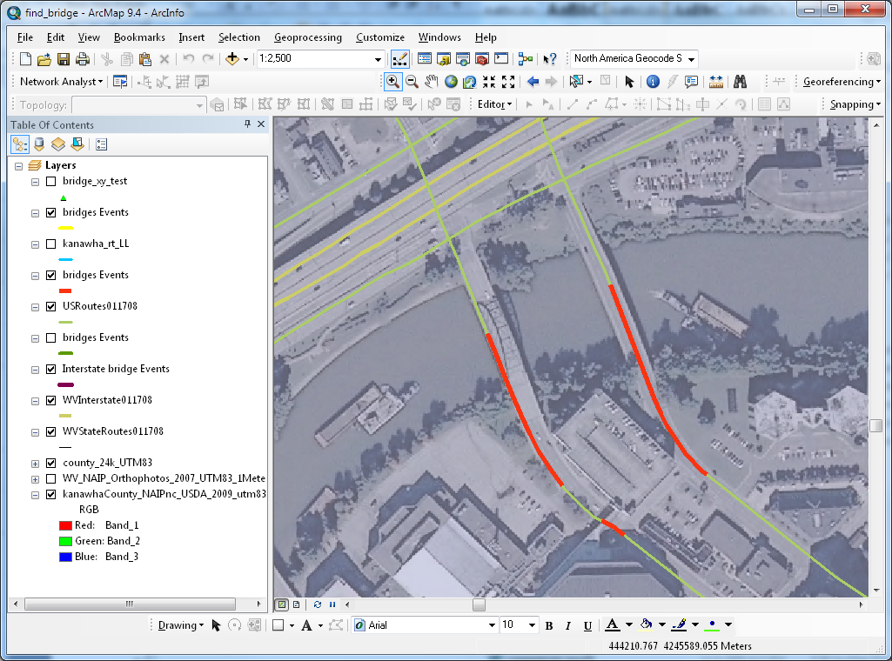
Figure 16. RIL Bridge Event on SAM Routes

10.3 Navigable Network and Routing (Path finding)
The edit centerline feature class was also used to create a network dataset that tested its capability for network functionality such as simple path finding. Creating a road network requires a unique set of attributes depending upon the desired functionality, as discussed in section 5.4. This component was intended to test potential routing, service area and drive time applications. Specifically, the intent was to test the data with a problem question: "Which asphalt plant is closest to the construction site?" There are several GIS techniques that could be used to solve this problem. Utilizing the Network Analyst extension, creating a Service Area is one task that can be performed on a network dataset. Though the origin locations were estimated, Figure 17 shows two distinct service areas that were evaluated for distance against the road network, and can be used to answer the problem question. However, route finding using this data as is results in a reduced level of accuracy and capability. Advanced path finding, which would provide driving directions, requires additional attribute information as well as additional feature classes, such as intersection and turn restrictions, as discussed in section 5.4 Currently, neither the WVDOT or the SAM data can currently support these advanced functions. 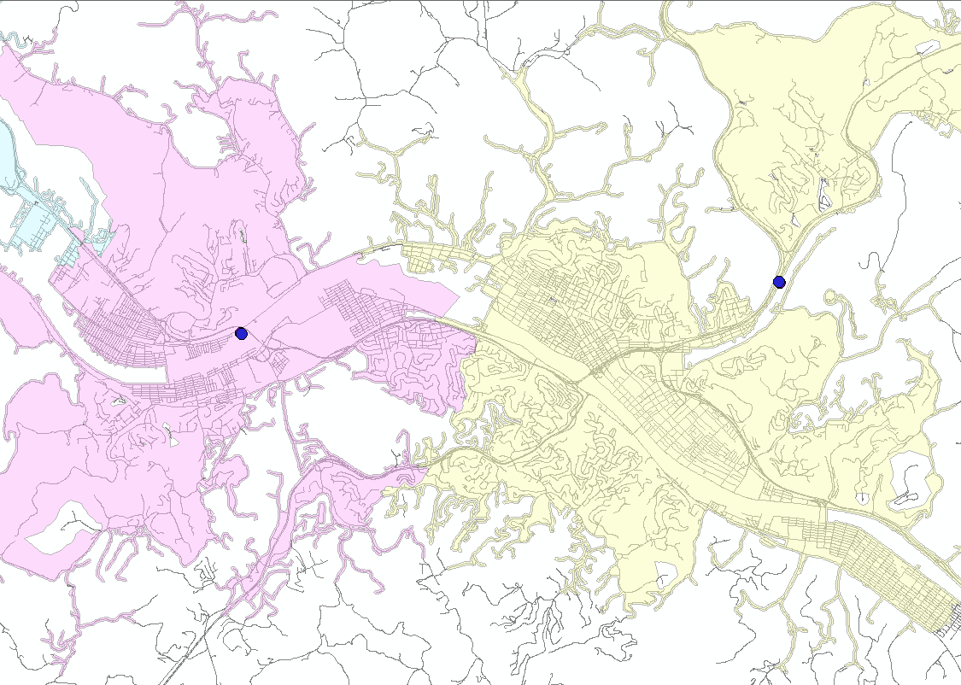
Figure 17. Service areas from SAM network

11. Summary and Conclusions
It is feasible to integrate WVDOT road centerline and the SAM dataset to create and maintain a single, statewide road centerline dataset that can meet most of the requirements of the WVDOT. At the beginning of the process, it is important to review existing data as well as identify any DOT requirements and develop an LRS and GIS data model. The revised/improved UNETRANS data model can be successfully implemented to accomodate WVDOT RIL system requirements. The data model will minimize any impact on existing WVDOT business processes and improve/enhance them. Using the advantage of Edit and Publish geodatabase design practices, the DOT can continuously develop and perfect the data model and migrate from the old system in stages. At the same time, the DOT can provide data to users and applications without interrupting their services.
Creating and maintaining a statewide dataset that includes the attributes (e.g., one way roads, turn restrictions, etc.) required to support full automated routing (traversing) would be challenging and costly. These attributes do not exist in publicly available data but can be acquired from commercial vendors. Integrating SAMB road centerlines will add connectivity, segmentation, and address ranges to a statewide centerline dataset which are requirements of routing. These will provide other benefits such as distance analysis and geocoding. The DOT should approach the routing requirement as a long-term project and develop an action plan to achieve that goal.

12. Recommendations

12.1 Documentation
The importance of current and detailed documentation is essential for planning, implementing and maintaining an accurate transportation database. Specific documentation, such as the WV DOH Business Rules and LRS Implementation Rules (as mentioned in section 4.2) are necessary for further progress and implementation of a comprehensive transportation GIS. It is important that improvements and advancement of documentation and procedures is made, which can help guide any data model specification, future research, and any policies between the SAM and WVDOT. It is recognized that the WVDOT has recently contracted with the ESRI Enterprise Advantage program. It is encouraged that this contractor provide expertise in writing a refined set of business rules, in addition to providing experiences from other states who have accomplished similar integration and data model development tasks. It is also recommended that WVDOT creates and maintains minimum level metadata for all internal use and published GIS Datasets.

12.2 Inter-agency Coordination
Pursuit of an integrated E-911 database (SAM) and WVDOT road database is feasible and has been demonstrated by other states such as Ohio. E-911 and Transportation agency coordination is also the future direction of the industry, with a focus on cost savings, reduction of duplication of effort, increased data usability and the increased needs of the security sector. Though data integration between SAM and WVDOT datasets are technically feasible, a considerable level of coordination and commitment between WVDOT, the SAM and individual counties needs to be established. The long term viability of an integrated dataset is dependent upon strong data usage, editing, and sharing policies which are developed to reflect the needs and workflows of the participating agencies. It is recommended that WVDOT pursue a high level of open dialogue with the Department of Military Affairs and Public Safety in order to establish future cooperation. Specifically, needs of the SAM and willingness to participate on the county level will need to be addressed. It may be necessary for the WVDOT be able to provide a benefit to the counties, such as help in data collection or validation.

12.3 Data Model
The results of the data analysis and comparative research of various data models has allowed us to reach a recommendation that the WVDOT utilize an Improved UNETRANS data model.The final data model details will need to be determined by the WVDOT, based upon many factors. Consideration of this report, existing documentation, the WV DOT Business Rules, LRS Procedure rules, the SAM Data model, and case studies should be used for development of the final data model. Data model development may also be aided by additional research in conjunction and concurrent development of a larger scale pilot.

12.4 All Roads
It is the intent of the WVDOT of having a single, state-wide road centerline database. The existing LRS does not require all roads, but having all roads in a single database is necessary for many applications, including the use of a navigable network. SAM road data would most likely be the most current data source publicly available that can fulfill this requirement. It should be noted that it is not current or complete. Alternative data sources may be needed in order to supplement the SAM road data and create a 100% all roads network. Though need will most likely be limited, alternative sources could include data collected by WVDOT field engineers, utilizing GPS, or collected from aerial photography. Recognizing that aerial photography is expensive, it may be sourced from national projects such as the 2009 NAIP or from individual counties that have acquired their own data.

12.5 Further Research and Phase2 Pilot
A second pilot is recommended because certain issues were not addressed as part of this study. While the data integration was tested and proven to be feasible, no exchange of data took place between WV DOT and SAM. Also, no actual workflow integration was tested in this pilot. In addition, potential issues identified in this study, such as cross county edge-matching issues will need to be resolved. A district-wide pilot is recommended to best represent the conditions and workflow of the actual integration. Tasks and problems of performing edge-matching will need to be resolved as a requirement of integration. In addition, a second pilot could be used to determine the feasibility of creating an advanced routable network dataset. Time and costs could be estimated by creating needed attributes such as travel restrictions, traversal time, junctions and a Turns element (table or geometry).
Prior to the next phase, the WV DOT should define a preliminary Business Rules document, LRS Procedure rules and specific data model. This information would then guide the second phase pilot. The goal of the second phase would be to help develop and refine the WVDOT data model and procedures, as well as make any necessary changes to the SAM data model. This would be done by implementation of real workflows and integration between the WV DOT and SAM.
The second phase would help resolve particular details of the data model, workflow procedure (and documentation) issues of data sharing between WVDOT and SAM, and help guide the final WVDOT and SAM cooperative policy. In addition, time and cost estimates could be generated to define how long a statewide integration may take. The second phase of the pilot would require extensive resources for data editing. WVDOT, RTI, WVGISTC or any combination of staff should be made available for data editing.

Appendix A: Glossary
The definitions in this glossary are derived from the following sources.

[1] Federal Highway Administration, and GIS/Trans. Ltd. 1999. Federal Highway Administration Linear Referencing Practitioners Guidebook. [S.l.]: GIS/Trans Ltd.
[2] Highway Research Board, and National Academy of Engineering. 1974. Highway Location Reference Methods, National Cooperative Highway Research Program (NCHRP) Synthesis of Highway Practice 21. Washington, D.C.: Highway Research Board, National Academy of Sciences.
[3] United State Geological Survey. 1999. Spatial Data Transfer Standard (SDTS). Reston, Va.: U.S. Dept. of the Interior, U.S. Geological Survey.
[4] Vonderohe, A. P., C. L. Chou, F. Sun, and T. M. Adams. 1997. A generic data model for linear referencing systems. In Research Results Digest 218. National Cooperative Highway Research Program. Transportation Research Board.
[5] Wikipedia contributors, Wikipedia, The Free Encyclopedia, http://en.wikipedia.org/ (accessed May 11, 2010).
[6] Wood, Stearns J., and Data West Research Agency. 2000. A practitioner's guide to GIS terminology : a glossary of geographic information system terms. University Place, WA: Data West Research Agency.

Anchor Point: A zero-dimensional location that can be uniquely identified in the real world in such a way that its position can be determined and recovered in the field. Each anchor point has a “location description” attribute that provides the information necessary for determining and recovering the anchor point’s position in the field. Forms of location descriptions can vary and can be quantitative or descriptive or both, (e.g., the intersection of the centerlines of Oak Street and Maple Street; and 1.2 miles south of the Post Office on the centerline of Route 9). Anchor points can be understood as one-dimensional control points, in that they serve the same purpose as geodetic control points in two and three dimensions. That is, they are the fundamental objects to which all other objects are directly or indirectly tied [3].
Anchor Section: A continuous, directed, nonbranching linear feature, connecting two anchor points, whose real-world length (in distance metrics), can be determined in the field. Anchor sections are directed by specifying a “from” anchor point and a “to” anchor point. Anchor sections have a “distance” attribute, which is the length of the anchor section measured on the ground. Values are expressed in units of linear distance measure (e.g., kilometers). Anchor sections provide the fundamental referencing space. The collection of anchor sections in a given linear referencing system is analogous to the ellipsoid surface in a geodetic datum or the map projection surface in a two-dimensional Cartesian referencing system [3].
Dynamic Segmentation: A GIS function for modeling linear features in highway applications such as accident analysis and pavement management. The process has the ability to compute locations of events on linear features at run time (or dynamically) in linear measure (e.g. milepost). Event features, the segmentation points, are not stored in the geometry of the coverage but are derived as needed. Route-system features and event handling commands provide the dynamic segmentation capability within GIS systems to dynamically locate events on linear features that are obtained from attribute tables of events for which distance measures are available. Both point and linear events can be located on routes; lane closure is an example of a linear event and the accident location is an example of a point event [6].
Entity-relationship diagram: In software engineering, an entity-relationship model (ERM) is an abstract and conceptual representation of data. Entity-relationship modeling is a database modeling method, used to produce a type of conceptual schema or semantic data model of a system, often a relational database, and its requirements in a top-down fashion. Diagrams created by this process are called entity-relationship diagrams, ER diagrams, or ERDs [5].
Event: A feature, characteristic or phenomenon that occurs along a roadway (or traversal) and is described by attributes stored in a database, including its location specified by a linear referencing method [1].
Linear Datum: The complete set of anchor sections and anchor points, constituting a mutually exclusive, totally exhaustive, ordered set of linear locations. The linear datum relates the database representation to the real world and provides the domain for transformations among linear referencing methods and among cartographic representations. There is a single linear datum. It is included in this data model because of the centrality of its concept to the overall model, not because there would necessarily be a number of instances that would have to be tracked in a database. Various versions of the linear datum might exist over time as changes in transportation facilities occur. No attributes are assigned to the linear datum [4].
Linear Event: A 1-dimensional event with location specified by a two linear measures along a traversal. A linear event must reference one ‘start’ and one ‘end’ reference point along the same traversal [1].
Linear Referencing Method: A location referencing method in with a location is specified as occurring on a uniquely identified linear feature (i.e., a traversal), at a set distance and direction from another point with a known linear measure (often the beginning of the traversal)[1].
Linear Referencing System: A location referencing system comprised of one of more linear referencing methods [1].
Link: A 1-dimensional object that is a topological connection between two nodes [3]. In common parlance, the term ‘link’ often refers as well to the linear feature that connects two nodes in a GIS centerline layer. However, a clear distinction is made for data modeling, where a ‘link’ is simply a topological connection, and a ‘line’ has shape and position and can be used for cartographic representation [1].
Location Referencing Method: The technique used to identify a specific point or segment of a roadway, either in the field or in the office [2].
Location Referencing System: Total set of procedures for determining and retaining a record of specific points along a roadway. The system includes the location referencing method(s) together with the procedures for storing, maintaining, and retrieving location information about points and segments on the roadways [2].
Node: A zero-dimensional object that is a topological junction between two or more links, or an end point of a link [3][4].
Point Event: A zero-dimensional event with location specified by a single linear measures along a traversal. A point event must reference one and only one traversal reference point [1].
Route: An ambiguous term which is often used to mean (a) a numbered or named highway (or roadway) as signed in the field, (b) a traversal with associated linear measures, or (c) both of these [1].
Segment: An ambiguous term referring to any portion of a roadway [1].
Traversal: An ordered and directed, but not necessarily connected, set of whole links. Coding conventions are required for establishing traversal directionality (in contrast to link directionality) and for specifying nonconnected traversals. No attributes are assigned to traversals [3].

Appendix B: Bibliography

Butler, Allison J. 2008. Designing geodatabases for transportation. 1st ed. Redlands, Calif.: ESRI Press.
Curtin, Kevin , Valerian Noronha, Mike Goodchild, and Steve Grise. 2003. ArcGIS Transportation Data Model (UNETRANS). In UNETRANS Data Model Reference.
Dueker, K. J. , and J. A. Butler. 1997. GIS-T Enterprise Data Model with Suggested Implementation Choices. Portland OR: Center for Urban and Public Affair, Portland State University.
Easa, Said, Yupo Chan, and American Society of Civil Engineers. Geographic Information Systems Committee. 2000. Urban planning and development applications of GIS. Reston, Va.: American Society of Civil Engineers.
Environmental Systems Research Institute. ArcGIS desktop 9.3 help. ESRI 1999. Available from http://webhelp.esri.com/arcgisdesktop/9.3/index.cfm?TopicName=welcome.
Federal Highway Administration, and GIS/Trans. Ltd. 1999. Federal Highway Administration Linear Referencing Practitioners Guidebook. [S.l.]: GIS/Trans Ltd.
Highway Research Board, and National Academy of Engineering. 1974. Highway Location Reference Methods, National Cooperative Highway Research Program (NCHRP) Synthesis of Highway Practice 21. Washington, D.C.: Highway Research Board, National Academy of Sciences.
Krätzschmar, Marc. 2010. Implementing the UNETRANS Data Model 20012010]. Available from http://proceedings.esri.com/library/userconf/proc01/professional/papers/pap975/p975.htm.
Litteral, Sean. 2007. WVDOT Strategic GIS Implementation Plan. edited by West Virginia Department of Transportation. Geospatial Transportation Information.
Miller, Harvey J, and Shih-Lung Shaw. 2001. Geographic Information Systems for Transportation: Principles and Applications. New York, New York: Oxford University Press.
SHL, and Mississippi Dept. of Transportation. 1996. Linear Refereencing System (LRS) Design and requirements: Mississippi Dept. of Transportation.
Vogt, Tim J., South Dakota. Dept. of Transportation. Office of Research, and Re Spec Inc. 1997. A Location referencing system to support data integration. Rapid City, SD: South Dakota Dept. of Transportation, Office of Research.
Vonderohe, A P, L Travis, R L Smith, and V Tsai. 1993. Adaptation of geographic information systems for transportation. In NCHRP Report 359, Transportation Research Board, National Research Council: Press.
Vonderohe, A. P., C. L. Chou, F. Sun, and T. M. Adams. 1997. A generic data model for linear referencing systems. In Research Results Digest 218. National Cooperative Highway Research Program. Transportation Research Board.
West Virginia Department of Transportation. GTI. About Highway Data Services 2009. Available from http://gis.wvdot.com/gti/HighwayData.aspx.
West Virginia Department of Transportation. Planning & Research. 2007. Codes for Road Inventory File.
Wisconsin Dept. of Transportation. 1997. Location control management manual: Wisconsin Dept. of Transportation.

Appendix C: Linear Referencing System Questionnaire
LINEAR REFERENCING SYSTEM QUESTIONNAIRE
- Organizational Information
  - What office is responsible for development and maintenance of the agency's linear referencing systems? Describe its responsibilities.
WVDOH has been using same Linear Referencing Method (LRM), which is a base-offset (named route/milepoint), since it took over roads from Counties in 1930s and hasn’t changed how they specify locations along roadways. Mainframe application, Road Inventory Log (RIL), was developed to manage LRS since 1970 and DOH is developing a new RIL to migrate old system. RIL will serves as the enterprise transportation database. Geospatial Transportation Information (GTI) under Program Planning and Administration Division is responsible for RIL. The Highway Data System (HDS) unit under GTI processes addition, change or abandonment requests from the Districts and updates the roadway inventory records as Commissioner Orders are issued. Improvements are also updated to the Roadway Inventory File as received either from the Districts in the form of PJ-101, PJ-103 or by way of field notes generated by the regular field crew inventories. Other roadway history records dating back to 1933 including maps, scroll records, microfilmed documentation, correspondence files and official Commissioner Orders are also maintained in the work area. A Local Name Listing is updated as needed in coordination with the Districts and their respective County 911 organizations that have authority over the local name determination. The unit is also responsible to perform the functions necessary to support quality data needed to deliver the annual Public Certified Mileage Report and the Highway Performance Monitoring System (HPMS) submittal as per FHWA requirements and guidelines. The HPMS submittal is an expanded representation of the Certified Mileage and the data are used extensively by FHWA in the analysis of highway system condition, performance, and investment needs that make up the biennial Condition and Performance Reports to Congress. GIS unit, another GTI unit, is responsible for maintaining software and hardware of RIL.
  - What office is responsible for coordinating GIS activities? Describe its responsibilities.
GTI section
- Overview of Current Use of Linear Referencing
  - Can you name and briefly describe each of the linear referencing systems currently in use in your agency?
Note: it's important to get the "name" by which each LRS will be referenced Detailed descriptions come in the next section.
No official name for LRS (or RIL).
  - We'll go over each of the LRSs in detail, but what are the major issues you face, as a department, with regard to linear referencing?
For example: managing updates to the LRS and historical data, integration of data using different LRSs, integration with GPS and other data types, implementation in GIS, development of referencing systems for local roads. etc.
No major issue was addressed by attendees.
  - What formal process, if any, was used for development of your linear referencing system(s), e.g., Information Engineering?
No formal process.
  - Describe any current initiatives you have for revising / expanding your linear (and location) referencing.
No formal process
  - Do you have any standards or other documentation on your agency's linear (or location) referencing strategy and systems? • Request copies of any available documentation.
No official documentation.
- Detailed Description of Each LRS
  - General Over View
    - How is this LRS referred to (its ''name'')?
Road Inventory Log.
    - What type of LRS is this (route/milepoint, link/node, control section, etc.).
Route/Milepoint
    - Briefly describe how the LRS is managed (e.g., computer application, hardware/software, etc.).
A mainframe CICS application is used to manage LRS control files and key event database, flat file system. New RIL in MSSQL RDBMS will replace current system as soon as on-going RIL improvement project is completed.
    - What documentation describes this LRS (obtain copies)?
No
    - What documentation exists for end-users, on how to determine and record locations, standard database fields, etc.?
Codes for Road Inventory File and HPMS manual from FHWA
    - How long has this LRS been in use?
Since 1970s
    - Has it undergone any major revisions? If so, explain.
No.
    - Whose responsibility is it to maintain and update the LRS, and to assure correct use of the LRS?
HDS unit. End of year, when the annual Public Certified Mileage, the HPMS, and the biennial Condition and Performance Reports are due, HDS unit also does cross quality check.
  - Use of this LRS
    - Who in this agency uses this LRS (e.g., what management systems), and what information is referenced to this LRS:
General roadway characteristics system Right-of-way
Traffic management (counts, volumes, etc.) Videolog
Congestion management Permit routing
Accidents Maintenance
Bridges Local road inventory
Pavement management Rail (crossings, etc.)
Highway / work program development Air / aviation
Project monitoring system Public transportation
Engineering / design Construction management
HPMS Sign inventory
Other:
    - What end-user applications (GIS or other) make use of this LRS (work program development, etc.)?
All of GIS web and desktop applications, HPMS applications, Project tracking application, PRS & PRS master (construction/engineering/right-of-way applications), etc
    - To what degree is this LRS used and/or maintained and updated by DOT district offices?
Division and district initiate LRS change process and also responsible for field validation of any LRS changes.
  - Route definition, coding, resolution
    - How are routes defined? What roadway sections make up a route, and how are start and end points-determined?
By state law, sequential, commissioner order, design specs, ADT
    - To which roadways does this LRS apply (state system, county, other public roads, etc.)? Note: specific cases like ramps and service roads are dealt with below.
Any roadways (approximately 37,000 miles) State owns.
    - How are the routes IDs coded? Note: be specific concerning the meaning of individual characters and codes, the use of leading zeros, justification within the field, etc. Any documentation?
New System
Route ID _ _ - _ - _ _ _ _- _ _ - _ _
1 2 3 4 5 6 7 8 9 10 11
Where the suffix 1 and 2 represent the county and suffix 3 is for the sign system. Suffix 4, 5, 6, and 7 would make up the route number/use leading zero and suffix 8 and 9 would be the sub route number. Suffix 10 and 11 would make up the supplemental description of the route. When field is N/A zero is used.
Old system in mainframe
Route number is 3 digits instead of 4 digits
  - Linear Referencing System control
LRS control files (or tables, or diagrams) define the key components which control the LRS, and the relationships between them. LRS control elements may include routes, links, control points, mileage equations or other components. Data tables (or event tables) are not part of the LRS control.
    - What documentation describes the LRS control files (or tables, diagrams, etc.)?
SLD and commissioner order
    - Describe the control files used to manage the LRS (or reference the documentation).

    - Are mileage equations used? If so, describe their use and function.
No.
    - Describe any other tables that comprise the LRS database, and the database structure.
Mainframe application –
RIL -
    - What are the strengths and weaknesses of the LRS control database?
Weakness: Historical record keeping once a year back to 1996. flat file
  - Field practices / data collection
    - Are mileposts or reference posts (i.e., signs) used in the field? Yes No lf so:
- When were they established?
- Have they been maintained, and are there any maintenance issues?
Interstate and some US & State routes have mileposts
- Are they considered to be accurate?
Every 1 mile with 0.1 mile accuracy
    - How are 'correct' route lengths determined in the field (e.g., use of DMIs)?
Use of DMI for at least 10 years
    - What "centerline" is used to determine road length (e.g., right lane)?
Design mile is based on the center of the road. In the RIL, road length is based on a measured mile and every three to five years they remeasure.
    - Where exactly are the start and end points of routes (e.g., within an intersection)?
State & county boundary and Intersections.
    - How are the measures (the "locations") of point and linear events determined:
- in the field (e.g., mileposts or reference posts)?
Off-set from known point
- in the office (e.g., Straight Line Diagrams, 'route log' or 'log mile' listings, or computer applications)?
SLD, field note, and commissioner order
    - If Straight Line Diagrams are used: Yes
- do they have route IDs on them (e.g., as used in the LRS control database)?
Yes, but it is different from RIL or mainframe. SLD route Id consists of street name, route, sub route, county, and district.
- do they have milepoints on them? Yes
    - What problems or issues are there in the field (or office) for those using the LRS for their data collection?
Inconsistent use of same route name in field note and other records
    - What are your standards (or practices) for linear measurement accuracy (e.g., accuracy tolerance in urban/rural areas, accuracy for different feature types, etc.)?
There are standards and will request a copy.
    - If a route is re-measured and found to differ from the old length, is there a tolerance below which the official length is left unchanged? N/A
  - GIS implementation
    - What GIS software is currently used? ESRI
    - What process was used to "implement" this LRS using GIS?
DynSeg and Event tables via Route-mile
    - Have all roads handled by the LRS been implemented in GIS? Yes.
    - Describe the GIS base map (centerline file) used:
- Original source of centerlines:
Interstate, US, State - GPS points & lines from Roadware
County Routes, FANS, HARP, State Park and Forest Roads – SAMB digitized road centerline based on aerial Imagery, head-up digitizing using SLD info and aerial imagery.
- Scale: 1:4800
- Development process:
- Accuracy/quality:
- Other:
    - Quality control of the GIS base map:
- What quality control has been done on the LRS implementation in the GIS base map?
GIS unit use RIL, SLD, aerial imagery and commissioner order to control quality.
- Have mismatches been identified between field-measured lengths and GIS lengths?
N/A, DOH only implement field-measured lengths on GIS system. Sometimes GIS length is used for field measure verification/comparison purpose only.
- Are there discrepancies between the LRS and the coding in the GIS base map (e.g., differences in section lengths, problems with interchange alignments, etc.)?
    - GIS base map update procedures:
- What update procedures are used for the GIS base map?
GIS unit updates/changes GIS base map, when HDS unit receives any change/update request via commissioner order, field note, or district request. Any submitted requests are required supporting documents indicate/illustrate/describe a location change (currently paper maps but electronic file such as CAD and GIS file will be required)
- Is the GIS base map kept synchronized with the LRS (e.g., if the linear measures for a route are updated in a relational database)? If so, what procedures are used?
No, GTI is working on backlogs but will be available to synchronize with the LRS once when backlogs are clear. There are no formal procedures yet.
    - If local roads (some or all) are included, describe: Not included yet.
- Source of the local roads centerlines: Possible source is SAMB road centerlines
- How local road centerlines were integrated: segment & relate
- How local roads (and their routes) are updated and maintained:
E911 process but not all counties are capable of updating and maintaining local roads due to resources constrain
- Other:
    - To what degree have the measures in the GIS been calibrated? Not calibrating yet.
    - How accurate (or inaccurate) are the locations of features as displayed in the GIS? Is this a problem?
Accuracy is reasonable from 1:4800 to 1: 24000.
    - How is linear referencing currently being used in the GIS:
Data display/mapping
Database query (e.g., select a location or road section on the map and get a report)
Determination of linear measures (e.g., to specify crash locations)
Automated data input (e.g., including graphic specification of locations)
Other custom applications (construction project information, work program, etc.)
Quality control of data Integration and analysis of different event tables (e.g., identify accidents associated with specific pavement conditions)
To convert between different LRSs (Note: LRS conversion does not require GIS, but a GIS application is often used)
Other:
    - What (other) issues or problems have there been with the GIS implementation?
No or insufficient data, data format conversion, emerging technologies.
    - What have been the (other) major benefits and successes of the GIS implementation?
Hussein’s Slide
  - Special roadway cases
How does your LRS (and GIS base map) handle each of the following special cases:
    - Divided highways
- How are attribute locations specified along the separate travel ways (e.g., an accident which occurs in the north-bound lane)? Only in GIS system
- If divided highways are not specially handled, are there problems due to the separate travel ways having somewhat different lengths/measures? RIL has only one length
- If divided highways are specially handled in the LRS, what constitutes a 'divided highway'? (E.g., only highways with full access control? Highways with a certain type of median?)
In RIL and LRS, all Interstate highways and any 4 lane of greater roadways with median are a divided highway. However, there is no dual record for each direction in RIL. Pavement type and width and grade width are only attributes info in RIL for each direction
In SLD, if there is significant disparity between each travel directions, separate SLDs are require to depict additional info. In GIS basemap, Interstate and US highway have dual geometry.
- Are routes defined for separate travel ways? If so, how are the measures determined, and are they correlated between the different travel directions?
    - Ramps
- Are ramps included in the LRS? No.
- Where do the measures for a ramp begin (e.g., at the gore point)?
Hasn’t collect the measures for ramp yet but the system will use a measure where ramp start at the gore point.
- Are acceleration/deceleration lanes considered to be part of a ramp? Yes
    - Approaches (at intersections, including ramp intersections). Especially, how is a 'Y' intersection handled? Is a separate route defined for one of the legs?
    - Alternate or overlapping routes
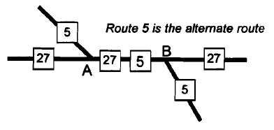
Route 5 is the alternate route 88
- For the case illustrated above, does the LRS use coincident routes (measures increase for both routes along the common section), or is there a gap for the alternate route?
No
- Are multiple road/route name aliases supported for alternate routes?
No, but the new system (RIL) supports multiple road/route name aliases.
- If a 'primary' route is designated, how is it selected?
Typically higher functional class and lower number route are designated as the primary route but there are some exceptions for example I64 and I77 on WV Turnpike.
- Are attributes (events) along the common section associated with only the primary route, or can they be associated with either route?
All attributes (events) are only associated with primary route. However, the new system (SQL RIL) will have any to link with the secondary route
- Suppose there is a gap for the alternate route. For example, suppose the measures for route 5 stop at 2.5 miles at point A, then continue from 2.5 miles at point B. In this case, the location 'milepoint 2.5 on route 5' would be ambiguous, existing at 2 places (points A and B). Is this the case for this LRS? __ Yes _x_ No If so:
- Has this posed any problems for you (e.g., is it possible for an accident at point A to be ambiguously located at '2.5 miles along route 5)?
- If there are such gaps, do these potentially cause problems for analysis, such as for identifying high accident locations? For example, could a high accident location along route 5 span both legs, thus including two separate intersections?
    - If your routes are defined by county (or other jurisdiction), what happens when a route exits and reenters a county? Are there ambiguous measures (as there can be for a route with a spatial gap)? County routs are defined by county boundary but there are exceptions. There is no gap for a route. The measures continuously increase even if a route exit and reenter a county.
    - One-way pairs (i.e., where a road divides into 2 one-way sections of different length)
No case.
- If a separate route is defined for one leg of a one-way pair, what criteria determine if the leg is to become a separate route?
- Are there any route ID coding conventions?
    - If local roads are included, are there any special accuracy or maintenance considerations?
Local roads are not included unless they are part of state roads.
    - Layered or tiered roads (e.g., a 2-level bridge). NO
    - Service roads (which parallel a limited access highway, provide a buffer the limited access and local roadway). Not in WV.
    - Individual lanes (including HOV lanes).
Currently stored as attributes of logical centerline.
    - Associated facilities (truck runoff ramps, rest areas, emergency V-turns, etc.).
Not in RIL nor mainframe app.
    - Rotaries: how is the situation illustrated at right addressed, where a portion of a rotary doesn't belong to any of the intersecting routes?
    - Cul-de-sacs: is a standard direction (clockwise or counterclockwise) used for determining the direction of increasing measures?
No standard direction yet.
    - Proposed highways: if measures are assigned, how are these integrated with the base map?
Separated file. Unofficial supplement code is assigned.
    - Locations of offset features (i.e., perpendicular offset from a route).
Perpendicular offset from a route.
  - Attribute storage schemes
    - Is there a major, centralized ''roadway characteristics" database? If so, what is it called?
Mainframe app and RIL
    - Are event tables 'linearly normalized', 'linearly denormalized', or a hybrid?
Currently mainframe app is completely denormalized but the new system (RIL) will be normalized.
    - Are any QA/QC procedures used to:
RIL enhancement project will have QA/QC procedures
- Verify that a linear event table covers the entire network? For example, every section of roadway falls under a single jurisdiction; is there a routine to assure the 'jurisdiction' event table covers all roadways in the system?
- Verify that all event route IDs and milepoints are valid?
- Verify point events are not coded at ambiguous milepoints (i.e., at discontinuous routes that have continuous measures?
- Other?
    - Are there any barriers to database query or analysis associated with the database structure?
  - Updates to the LRS and management of historical data
    - Briefly, what process is used to update the LRS (not the GIS data), due to reconstruction, new construction, abandonments, re-measurements, etc.?
When construction is done, doc is submitted to GTI. Field crew is sent to verify the work. Then HDS enters the info.
    - Is there a system for tracking updates to the LRS over time? How are updates recorded?
Mainframe, it is possible to track when record was changed but not what record was changed. New system will have any to track these changes.
    - Is there a system for notifying end users of updates to the LRS, so their event tables can be updated?
No.
    - Are routes and/or events time stamped? Yes No If so, describe what the time stamps refer to (data entry data, effective/expiration dates, etc.), and how they are used.
    - Are historical alignments (and/or routes) stored:
- in the LRS? No
- In the GIS data? No
    - Are there procedures for comparing the records of an event table to assure that events are 'synchronized' with the current LRS (i.e., to identify any records that reference routes or portions of routes which have been updated)? N/A
    - Are there procedures for keeping updates to the GIS network synchronized with updates to the LRS? In proposed work flow, GIS will be part of syn process.
    - Consider a specific example, a realignment with reduction in route length. Suppose that a reconstruction project between milepoints 1.0 and 3.0 of a 10.0-mile route eliminates 0.1 miles from the route.
- How are the route IDs modified? No.
- How are the measures (and/or routes) updated along the full length of the original route (e.g., does the original section from 0.2 to 10.0 miles now measure from 0.1 to 9.9 miles)? With commissioners order the measure updated.
- Are field markers updated (with new measures)?
If the change of length is greater than 0.5 mile.
- For on-line event tables (in the centralized "roadway characteristics" database), are the measures for events referenced to the updated route updated accordingly? If so, is the process automated or manual?
Yes. done manually
- How are updates handled for event tables other than in the centralized database (i.e., used by different divisions)?
Speed limit – traffic dept, assets – traffic, pavement & bridge – maintenance,
Tunnel – district office
    - Procedures used for other types of updates. Using the questions posed above under 4.9.8 as a model, how are each of the following cases updated in the LRS, with regards to the route IDs, measures, field markers, storage of historical data, etc.
- Roadway realignment with increase in length (any difference from the update process for a reduction in length, as in 4.9.8?):
- Change to the route identifier (e.g., if highway jurisdiction changes from state to county):
County route can be changed
- Correction to route measures without any change to the roadway alignment (e.g., due to remeasurement in the field):
- Addition of a new roadway (and route):
- Addition of a new portion to an existing route, and the end or beginning of the route:
- Deletion of an entire roadway/route:
- Deletion of a portion of a route, from the beginning, middle or end of the route:
Rename route name where a change happens
- Creation of a new node (e.g., due to addition of a new road), in the middle of a route, with a newly-determined measure:
    - What needs do you see for managing historical data, which are not currently being met?

- HPMS Submission
  - Have you developed a separate or modified LRS to meet HPMS submission requirements? If so, please elaborate.
No.
- Data Integration
  - Data transfer between information systems
    - Consider a roadway characteristic such as Average Annual Daily Traffic (AADT), which is typically used by many information systems. When new AADTs are determined, how are the new values transferred to other information systems (e.g., traffic modeling, bridges, railroad crossings, etc.)?
Each dept acquires from RIL
  - Integration of different LRSs
    - To what degree are your multiple LRSs integrated?
- Are you able to translate measures from one LRS to another? For which LRSs?
- Are you able to map features using different LRSs?
- Are you able to perform queries with custom applications, drawing from data sets using different LRSs?
- Are you able to perform ad hoc queries, from data sets using different LRSs?
    - What major problems and/or successes have you had integrating data located by different LRSs?
  - Integration with GPS and other geographically referenced data
    - Are you integrating GPS data with linearly referenced data? If so, please elaborate.
Some point features have GPS data.
    - Does your GIS base map have link attributes? If so, what are the attributes, and how are these integrated with linearly referenced data? NO
    - Are you integrating linearly referenced data with any point or polygon data (e.g., for any specific projects)?
Yes.
- Use of Related Technologies
  - Describe any GPS activities related to linear referencing, such as:
    - Refinement of the LRS measures? Yes
    - Refinement of the GIS base map? Yes
    - Resolution of discrepancies between the LRS and GIS base map?
    - Data collection? Yes

- Relationship to Other Modes of Transportation
  - Are you considering the use of linear referencing to support other modes of transportation, such as for supporting analysis and modeling of transit information?

Appendix D: WVSAMS Data Specification

This report will be provided digitally as reference material in .pdf format.

Appendix E: Data Model Relationship Types
From Butler, Allison J. 2008. Designing geodatabases for transportation. 1st ed. Redlands, Calif.: ESRI Press.
