Introduction to Programming Javascript and Interactive Mapping Using ArcGIS Javascript API
How I Stopped My Fear of Programming and Learned to Make Interactive Maps
Frank LaFone
2017

Slide 1 |  | ___________________________________  ___________________________________  ___________________________________  ___________________________________  ___________________________________  ___________________________________  ___________________________________
Slide 2 |  | ___________________________________  ___________________________________  ___________________________________  ___________________________________  ___________________________________  ___________________________________  ___________________________________
Slide 3 |  | ___________________________________  ___________________________________  ___________________________________  ___________________________________  ___________________________________  ___________________________________  ___________________________________
Slide 4 |  | ___________________________________  ___________________________________  ___________________________________  ___________________________________  ___________________________________  ___________________________________  ___________________________________
Slide 5 |  | ___________________________________  ___________________________________  ___________________________________  ___________________________________  ___________________________________  ___________________________________  ___________________________________
Slide 6 |  | ___________________________________  ___________________________________  ___________________________________  ___________________________________  ___________________________________  ___________________________________  ___________________________________
Slide 7 |  | ___________________________________  ___________________________________  ___________________________________  ___________________________________  ___________________________________  ___________________________________  ___________________________________
Slide 8 |  | ___________________________________  ___________________________________  ___________________________________  ___________________________________  ___________________________________  ___________________________________  ___________________________________
Slide 9 |  | ___________________________________  ___________________________________  ___________________________________  ___________________________________  ___________________________________  ___________________________________  ___________________________________
Slide 10 |  | ___________________________________  ___________________________________  ___________________________________  ___________________________________  ___________________________________  ___________________________________  ___________________________________
Slide 11 |  | ___________________________________  ___________________________________  ___________________________________  ___________________________________  ___________________________________  ___________________________________  ___________________________________
Slide 12 |  | ___________________________________  ___________________________________  ___________________________________  ___________________________________  ___________________________________  ___________________________________  ___________________________________
Slide 13 |  | ___________________________________  ___________________________________  ___________________________________  ___________________________________  ___________________________________  ___________________________________  ___________________________________
Slide 14 |  | ___________________________________  ___________________________________  ___________________________________  ___________________________________  ___________________________________  ___________________________________  ___________________________________
Slide 15 |  | ___________________________________  ___________________________________  ___________________________________  ___________________________________  ___________________________________  ___________________________________  ___________________________________
Slide 16 |  | ___________________________________  ___________________________________  ___________________________________  ___________________________________  ___________________________________  ___________________________________  ___________________________________
Slide 17 |  | ___________________________________  ___________________________________  ___________________________________  ___________________________________  ___________________________________  ___________________________________  ___________________________________
Slide 18 |  | ___________________________________  ___________________________________  ___________________________________  ___________________________________  ___________________________________  ___________________________________  ___________________________________
Slide 19 |  | ___________________________________  ___________________________________  ___________________________________  ___________________________________  ___________________________________  ___________________________________  ___________________________________
Slide 20 |  | ___________________________________  ___________________________________  ___________________________________  ___________________________________  ___________________________________  ___________________________________  ___________________________________
Slide 21 |  | ___________________________________  ___________________________________  ___________________________________  ___________________________________  ___________________________________  ___________________________________  ___________________________________
Slide 22 |  | ___________________________________  ___________________________________  ___________________________________  ___________________________________  ___________________________________  ___________________________________  ___________________________________
Slide 23 |  | ___________________________________  ___________________________________  ___________________________________  ___________________________________  ___________________________________  ___________________________________  ___________________________________
Slide 24 |  | ___________________________________  ___________________________________  ___________________________________  ___________________________________  ___________________________________  ___________________________________  ___________________________________
Slide 25 |  | ___________________________________  ___________________________________  ___________________________________  ___________________________________  ___________________________________  ___________________________________  ___________________________________
Slide 26 |  | ___________________________________  ___________________________________  ___________________________________  ___________________________________  ___________________________________  ___________________________________  ___________________________________
Slide 27 |  | ___________________________________  ___________________________________  ___________________________________  ___________________________________  ___________________________________  ___________________________________  ___________________________________
Slide 28 |  | ___________________________________  ___________________________________  ___________________________________  ___________________________________  ___________________________________  ___________________________________  ___________________________________
Slide 29 |  | ___________________________________  ___________________________________  ___________________________________  ___________________________________  ___________________________________  ___________________________________  ___________________________________
Slide 30 |  | ___________________________________  ___________________________________  ___________________________________  ___________________________________  ___________________________________  ___________________________________  ___________________________________
Slide 31 |  | ___________________________________  ___________________________________  ___________________________________  ___________________________________  ___________________________________  ___________________________________  ___________________________________
Slide 32 |  | ___________________________________  ___________________________________  ___________________________________  ___________________________________  ___________________________________  ___________________________________  ___________________________________
Slide 33 |  | ___________________________________  ___________________________________  ___________________________________  ___________________________________  ___________________________________  ___________________________________  ___________________________________
Slide 34 |  | ___________________________________  ___________________________________  ___________________________________  ___________________________________  ___________________________________  ___________________________________  ___________________________________
Slide 35 |  | ___________________________________  ___________________________________  ___________________________________  ___________________________________  ___________________________________  ___________________________________  ___________________________________
Slide 36 |  | ___________________________________  ___________________________________  ___________________________________  ___________________________________  ___________________________________  ___________________________________  ___________________________________
Slide 37 |  | ___________________________________  ___________________________________  ___________________________________  ___________________________________  ___________________________________  ___________________________________  ___________________________________
Slide 38 |  | ___________________________________  ___________________________________  ___________________________________  ___________________________________  ___________________________________  ___________________________________  ___________________________________
Slide 39 |  | ___________________________________  ___________________________________  ___________________________________  ___________________________________  ___________________________________  ___________________________________  ___________________________________
Slide 40 |  | ___________________________________  ___________________________________  ___________________________________  ___________________________________  ___________________________________  ___________________________________  ___________________________________
Slide 41 |  | ___________________________________  ___________________________________  ___________________________________  ___________________________________  ___________________________________  ___________________________________  ___________________________________
Slide 42 |  | ___________________________________  ___________________________________  ___________________________________  ___________________________________  ___________________________________  ___________________________________  ___________________________________
Slide 43 |  | ___________________________________  ___________________________________  ___________________________________  ___________________________________  ___________________________________  ___________________________________  ___________________________________
Slide 44 |  | ___________________________________  ___________________________________  ___________________________________  ___________________________________  ___________________________________  ___________________________________  ___________________________________
Slide 45 |  | ___________________________________  ___________________________________  ___________________________________  ___________________________________  ___________________________________  ___________________________________  ___________________________________
Slide 46 |  | ___________________________________  ___________________________________  ___________________________________  ___________________________________  ___________________________________  ___________________________________  ___________________________________
Slide 47 |  | ___________________________________  ___________________________________  ___________________________________  ___________________________________  ___________________________________  ___________________________________  ___________________________________
Slide 48 |  | ___________________________________  ___________________________________  ___________________________________  ___________________________________  ___________________________________  ___________________________________  ___________________________________
Slide 49 |  | ___________________________________  ___________________________________  ___________________________________  ___________________________________  ___________________________________  ___________________________________  ___________________________________
Slide 50 |  | ___________________________________  ___________________________________  ___________________________________  ___________________________________  ___________________________________  ___________________________________  ___________________________________
Slide 51 |  | ___________________________________  ___________________________________  ___________________________________  ___________________________________  ___________________________________  ___________________________________  ___________________________________
Slide 52 |  | ___________________________________  ___________________________________  ___________________________________  ___________________________________  ___________________________________  ___________________________________  ___________________________________
Slide 53 |  | ___________________________________  ___________________________________  ___________________________________  ___________________________________  ___________________________________  ___________________________________  ___________________________________
Slide 54 |  | ___________________________________  ___________________________________  ___________________________________  ___________________________________  ___________________________________  ___________________________________  ___________________________________
Slide 55 |  | ___________________________________  ___________________________________  ___________________________________  ___________________________________  ___________________________________  ___________________________________  ___________________________________
Slide 56 |  | ___________________________________  ___________________________________  ___________________________________  ___________________________________  ___________________________________  ___________________________________  ___________________________________
Slide 57 |  | ___________________________________  ___________________________________  ___________________________________  ___________________________________  ___________________________________  ___________________________________  ___________________________________
Slide 58 |  | ___________________________________  ___________________________________  ___________________________________  ___________________________________  ___________________________________  ___________________________________  ___________________________________
Slide 59 |  | ___________________________________  ___________________________________  ___________________________________  ___________________________________  ___________________________________  ___________________________________  ___________________________________
Slide 60 |  | ___________________________________  ___________________________________  ___________________________________  ___________________________________  ___________________________________  ___________________________________  ___________________________________
Slide 61 |  | ___________________________________  ___________________________________  ___________________________________  ___________________________________  ___________________________________  ___________________________________  ___________________________________
Slide 62 |  | ___________________________________  ___________________________________  ___________________________________  ___________________________________  ___________________________________  ___________________________________  ___________________________________
Slide 63 |  | ___________________________________  ___________________________________  ___________________________________  ___________________________________  ___________________________________  ___________________________________  ___________________________________
Slide 64 |  | ___________________________________  ___________________________________  ___________________________________  ___________________________________  ___________________________________  ___________________________________  ___________________________________
Slide 65 |  | ___________________________________  ___________________________________  ___________________________________  ___________________________________  ___________________________________  ___________________________________  ___________________________________
Slide 66 |  | ___________________________________  ___________________________________  ___________________________________  ___________________________________  ___________________________________  ___________________________________  ___________________________________
Slide 67 |  | ___________________________________  ___________________________________  ___________________________________  ___________________________________  ___________________________________  ___________________________________  ___________________________________
Slide 68 |  | ___________________________________  ___________________________________  ___________________________________  ___________________________________  ___________________________________  ___________________________________  ___________________________________
Slide 69 |  | ___________________________________  ___________________________________  ___________________________________  ___________________________________  ___________________________________  ___________________________________  ___________________________________
Slide 70 |  | ___________________________________  ___________________________________  ___________________________________  ___________________________________  ___________________________________  ___________________________________  ___________________________________
Slide 71 |  | ___________________________________  ___________________________________  ___________________________________  ___________________________________  ___________________________________  ___________________________________  ___________________________________
Slide 72 |  | ___________________________________  ___________________________________  ___________________________________  ___________________________________  ___________________________________  ___________________________________  ___________________________________
Slide 73 |  | ___________________________________  ___________________________________  ___________________________________  ___________________________________  ___________________________________  ___________________________________  ___________________________________
Slide 74 |  | ___________________________________  ___________________________________  ___________________________________  ___________________________________  ___________________________________  ___________________________________  ___________________________________
Slide 75 |  | ___________________________________  ___________________________________  ___________________________________  ___________________________________  ___________________________________  ___________________________________  ___________________________________
Slide 76 |  | ___________________________________  ___________________________________  ___________________________________  ___________________________________  ___________________________________  ___________________________________  ___________________________________
Slide 77 |  | ___________________________________  ___________________________________  ___________________________________  ___________________________________  ___________________________________  ___________________________________  ___________________________________
Slide 78 |  | ___________________________________  ___________________________________  ___________________________________  ___________________________________  ___________________________________  ___________________________________  ___________________________________
Slide 79 |  | ___________________________________  ___________________________________  ___________________________________  ___________________________________  ___________________________________  ___________________________________  ___________________________________
Slide 80 |  | ___________________________________  ___________________________________  ___________________________________  ___________________________________  ___________________________________  ___________________________________  ___________________________________
Slide 81 |  | ___________________________________  ___________________________________  ___________________________________  ___________________________________  ___________________________________  ___________________________________  ___________________________________
Slide 82 |  | ___________________________________  ___________________________________  ___________________________________  ___________________________________  ___________________________________  ___________________________________  ___________________________________
Slide 83 |  | ___________________________________  ___________________________________  ___________________________________  ___________________________________  ___________________________________  ___________________________________  ___________________________________
Slide 84 |  | ___________________________________  ___________________________________  ___________________________________  ___________________________________  ___________________________________  ___________________________________  ___________________________________
Slide 85 |  | ___________________________________  ___________________________________  ___________________________________  ___________________________________  ___________________________________  ___________________________________  ___________________________________
Slide 86 |  | ___________________________________  ___________________________________  ___________________________________  ___________________________________  ___________________________________  ___________________________________  ___________________________________
Slide 87 |  | ___________________________________  ___________________________________  ___________________________________  ___________________________________  ___________________________________  ___________________________________  ___________________________________
Slide 88 |  | ___________________________________  ___________________________________  ___________________________________  ___________________________________  ___________________________________  ___________________________________  ___________________________________
Slide 89 |  | ___________________________________  ___________________________________  ___________________________________  ___________________________________  ___________________________________  ___________________________________  ___________________________________
Slide 90 |  | ___________________________________  ___________________________________  ___________________________________  ___________________________________  ___________________________________  ___________________________________  ___________________________________
Slide 91 |  | ___________________________________  ___________________________________  ___________________________________  ___________________________________  ___________________________________  ___________________________________  ___________________________________
Slide 92 |  | ___________________________________  ___________________________________  ___________________________________  ___________________________________  ___________________________________  ___________________________________  ___________________________________
Slide 93 |  | ___________________________________  ___________________________________  ___________________________________  ___________________________________  ___________________________________  ___________________________________  ___________________________________
Slide 94 |  | ___________________________________  ___________________________________  ___________________________________  ___________________________________  ___________________________________  ___________________________________  ___________________________________
Slide 95 |  | ___________________________________  ___________________________________  ___________________________________  ___________________________________  ___________________________________  ___________________________________  ___________________________________
Slide 96 |  | ___________________________________  ___________________________________  ___________________________________  ___________________________________  ___________________________________  ___________________________________  ___________________________________
Slide 97 |  | ___________________________________  ___________________________________  ___________________________________  ___________________________________  ___________________________________  ___________________________________  ___________________________________
Slide 98 |  | ___________________________________  ___________________________________  ___________________________________  ___________________________________  ___________________________________  ___________________________________  ___________________________________
Slide 99 |  | ___________________________________  ___________________________________  ___________________________________  ___________________________________  ___________________________________  ___________________________________  ___________________________________
Slide 100 |  | ___________________________________  ___________________________________  ___________________________________  ___________________________________  ___________________________________  ___________________________________  ___________________________________
Slide 101 |  | ___________________________________  ___________________________________  ___________________________________  ___________________________________  ___________________________________  ___________________________________  ___________________________________
Slide 102 |  | ___________________________________  ___________________________________  ___________________________________  ___________________________________  ___________________________________  ___________________________________  ___________________________________
Slide 103 |  | ___________________________________  ___________________________________  ___________________________________  ___________________________________  ___________________________________  ___________________________________  ___________________________________
Slide 104 |  | ___________________________________  ___________________________________  ___________________________________  ___________________________________  ___________________________________  ___________________________________  ___________________________________
Slide 105 |  | ___________________________________  ___________________________________  ___________________________________  ___________________________________  ___________________________________  ___________________________________  ___________________________________
Slide 106 |  | ___________________________________  ___________________________________  ___________________________________  ___________________________________  ___________________________________  ___________________________________  ___________________________________

Exercises

Exercise 1
In this exercise, we will be creating a basic webpage. We will link our css, javascript, and html files so that they are all working and interacting with one another.
- Create the file structure for your webpage. You will need to create a folder to hold all the files. We will call ours "Exercise-1". You can create this folder anywhere you wish. It may be easiest to locate if you create this file on your Desktop.
- Within the Exercise-1 folder we created, we will need to create an index.html file. This will be our main page that links everything together. (It needs to be called index.html because that is the default page browsers will look for within a folder). The easiest way to create one of these files is to open Notepad++ on your machine (This should be in your applications from the Start Menu) -> With a blank document open, click "File", choose "Save As" -> Find the folder you created to hold your webpage -> save your file in your folder with the File name "index" and the Type as "Hyper Text Markup Language file".
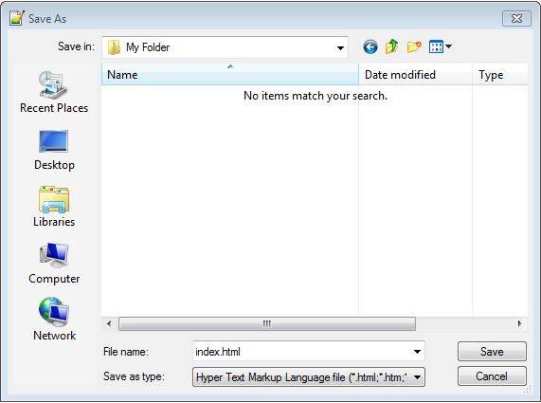
- Now we will create our css and javascript files. Since we may have multiple files, we will create folders to keep these organized. Create a "css" folder and a "js" folder in the same directory as your index.html file.
- Within your css folder, create a file called "style.css". Use the same method you used to create your index.html file. Be sure you're not accidentally overwriting you index.html file.
- Within your js folder, create a file called "script.js". Use the same method you used to create your index.html file.
- Currently, our main web folder should look like this:
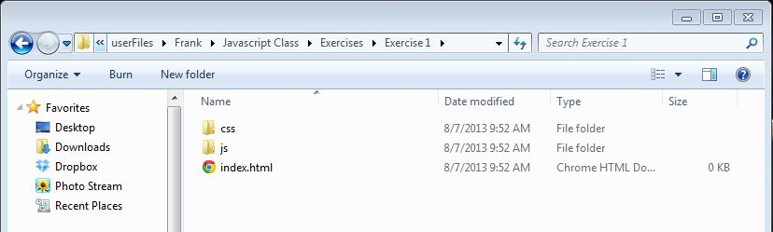
- Now let's write a basic html file and link our css and javascript files. Open your index.html file in notepad++.
- Write this code to set up your basic structure and link your css and javascript:
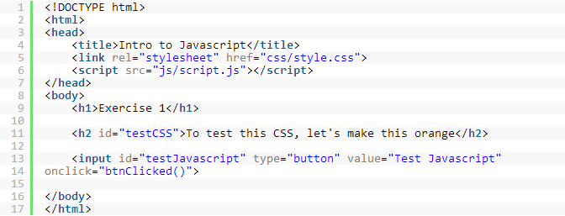
Question for thought: What would our process be if we wanted to add additional css and javascript files?
Answer: We would add css files to our css folder and javascript files to our js folder. From there, we would reference these files from index.html, just like we did in lines 5 & 6 of the example above.
- Open up your index.html file by double clicking on the file to open it in a browser. Your webpage should look similar to this:
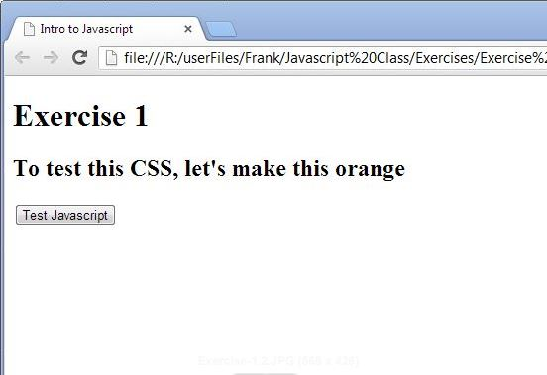
- Now let's make sure our css and javascript files are linked up properly. Open up your "style.css" file that we created earlier in notepad++. Let's target our h2 element with the id "testCSS" by typing:
- Open your index.html file to see if your css file has updated your webpage. It should now look like this:
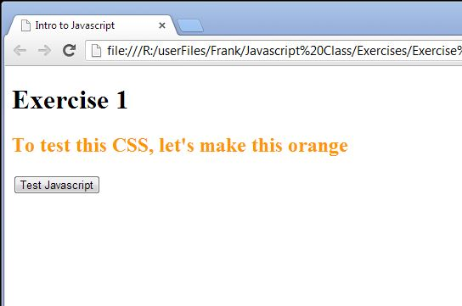
- Now let’s make sure your javascript file is properly working. Open up your “script.js” file that we created earlier in notepad++. Let’s target our button with the id “testJavascript”. If you notice, our button has an “onclick” attribute. This calls the “onclick” function in our javascript file. We will write that function now. To write this function, type:
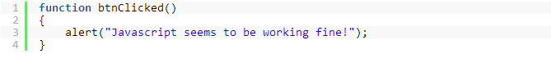
- Now open your index.html file again in your browser. To test if our function is working, click the button. You should see something similar to:
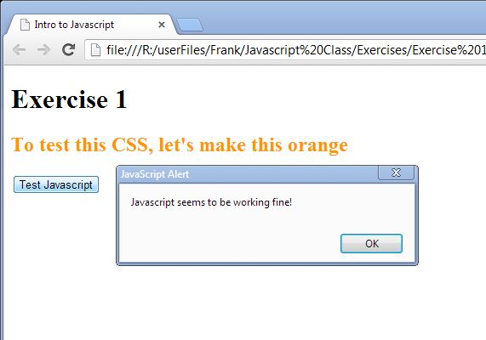
- We now have a basic webpage with working css and javascript.

Exercise 2
In this exercise, we will begin coding with jQuery and use it to make changes to our webpage. We will also go through operators, arrays, conditionals, and loops. We’ll build off of the files we created in Exercise 1.
- First, we will need to add jQuery to our html script. Unlike our other javascript file, jQuery is located on the internet and can be added by typing the URL as the source. We do not need to add anything to our js folder. In your index.html file, add jQuery right above your current script.js file. Your html file should now look like this:
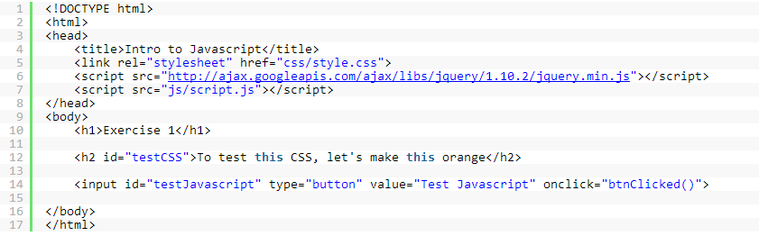
It is important you add jQuery above your other javascript files, because you cannot use jQuery in your other scripts if it is not loaded first.
- Let’s change our script.js file to see if jQuery was successfully included. Let’s replace your script.js file with:
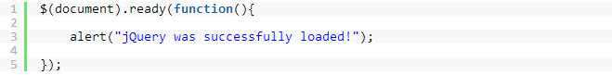
$(document).ready() is a jQuery function which executes when the webpage is fully loaded. We should put all of our jQuery inside of here so that we know that any elements we want to interact with have been fully loaded before we reference them.
- Open your index.html file in your browser to see if jQuery is working correctly. You should have an alert popup immediately after the page loads.
- Once jQuery is working, we can use it to interact with elements on our webpage. Let’s change the behavior of our current button in our html file. Replace our current button with this:
<input id="changeColor" type="button" value="Change Color">
Be sure you changed the id to “changeColor”.
- If you notice, we got rid of the “onclick” attribute. This will now be handled by jQuery. Let’s write a jQuery event handler for a click event on our button. In our script.js file, let’s replace our alert and add some code to where we have a file that looks like this:
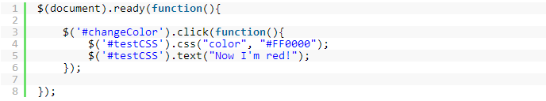
Here we are adding a click handle to the button with id “changeColor”. When that button is clicked, it runs a function which manipulates the h2 element with id “testCSS”. Here we are making that element red and changing the text.
- We can also hide and show elements on our page using jQuery. Let’s add these two buttons and two paragraphs to the body of our html page:
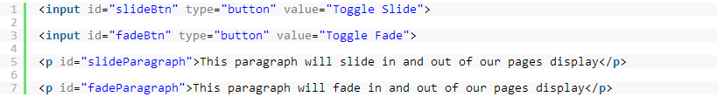
- Now that we’ve added these elements to our html page, let’s add some click handlers to our script.js file. We will also use some variable and operators to add text to the paragraph each time the toggle buttons are clicked. Add these lines to script.js:
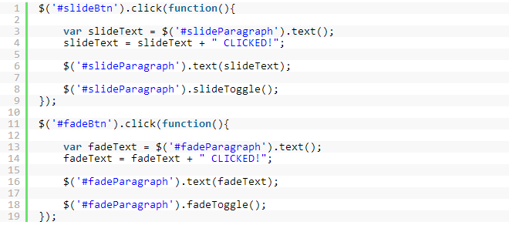
- Now test your webpage in the browser. Your toggle buttons should slide and fade your paragraphs. Also, each time you click a toggle button, your paragraphs should grow by one word each time.

Exercise 3
In this exercise, we will take a look at conditionals, arrays, and loops. We will add values to an array, test those values using a conditional, and take different actions depending on which condition that value meets. We will build from our Exercise 2 project.
- Let’s get started by adding these lines to the body of your html file:
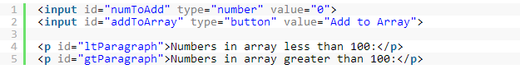
- Now we will add to our script.js file. Here, we will create a blank Array. Then we create a click handler for the “addToArray” button. This click handler will loop through all of the elements in the array and check if the number is greater than 100. The number will be added to the correct paragraph based on which condition it satisfies. Here is the code for the script.js file. This can be added anywhere in the $(document).ready function:
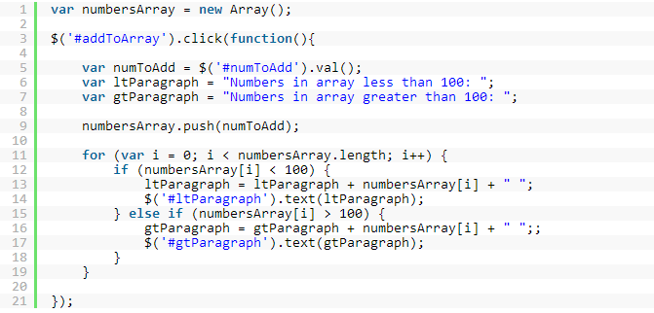
Note: We created the numbersArray outside of the addToArray click function because if it was inside the click function, it would create a new array each time the button is clicked. This would wipe out any previous values we had added to the array.
- Open your index file and add some values to your array. Try adding values less than and greater than 100.
- Now let’s add a “Clear” button to reset the array. In your html file, add the following line directly under your “addToArray” button:
- Now, let’s add to our script.js file to give this button the functionality we want:
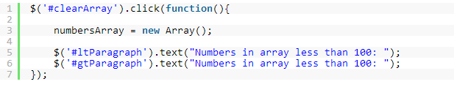
Note: We reset the paragraph text also, so that the old values of the array don’t still populate the text.
- Now test your html file in a browser. You should be able to add values to the array, test whether they are less than or equal to 100, and clear the array with our new button.

Exercise 4
In this exercise, we will create and loop through some objects. We will build off of our Exercise 3 webpage.

- Let's start by creating an object and printing it out onto the screen. Add these lines to the body of your index.html file:
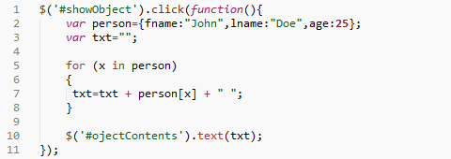
- Now we'll add to our script.js file. Here we will create an object and print it to the screen when our button is clicked:
- Test your index.html file in your browser to see if the object is printed to your screen.
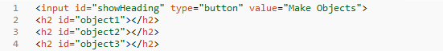
- Now we will create some more objects and use them to populate some content on our page. Let's add another button and some blank headings to the body of our index.html page:
- Now create a click handler in our script.js file for the button we just created. We will make 3 different objects and use those objects to give our blank headings some text and color:
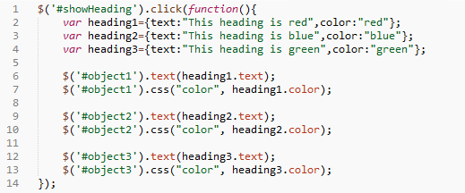
- Test your index.html file and make sure everything is working correctly.

Exercise 5
In this exercise, we will create our first map using javascript. We will be using ESRI's online tutorials as our guide. If you visit their site, you can copy and paste their code so that you don't make any tiny mistakes trying to type it yourself.
https://developers.arcgis.com/en/javascript/jstutorials/intro_firstmap_amd.html

- Let's start with a blank HTML template. Start with a template like this:
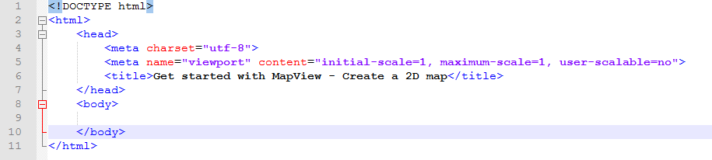
- To begin working with the ArcGIS API for JavaScript, add the following script and link tags inside the <head> tag. Insert these lines ABOVE your current css and javascript files so that they are loaded before your custom scripts:

- Now we add the script that creates the map, lines 11 through 30 in your file.
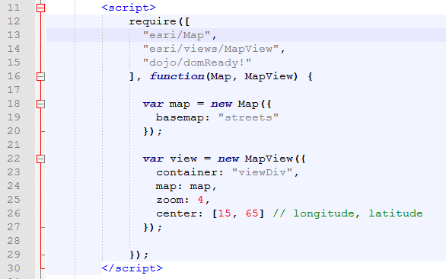
- We almost have a working map. Now we just need to add a div tag to our index.html file. This is where our map will go. Add this div to the <body> tag of your html file:
- Go ahead and test your page in a browser to see what you get. You should get a map that doesn't quite take up the whole screen. We will fix that with some css.

- Let's start with a blank css file. With a blank file, use these styles to style your map:
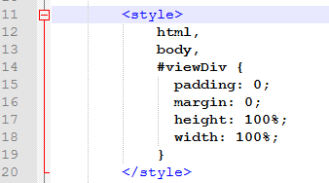
- Now reload your page in a browser to see if the map takes up the full screen. Congratulations, you should have your first working map using the javascript API.

Exercise 6
In this exercise, we will build off of the first map web map we made in Exercise 5. Try to mix two applications together to make a more complex application. This time, however, we will use the Sandbox to see how we can test applications online before development.
  - Visit the sample for Getting started with layers and click on the sandbox “Explore in the Sandbox” button
https://developers.arcgis.com/javascript/latest/sample-code/get-started-layers/index.html

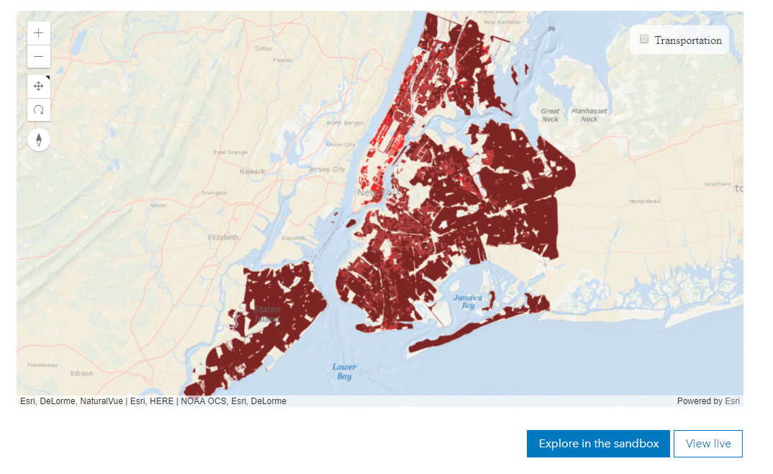
  - Now visit the Getting started with popups sample and click its “Explore in the Sandbox” button.
https://developers.arcgis.com/javascript/latest/sample-code/get-started-popup/index.html

  - We want to add the popup functionality from the Popups sample to the Layers sample.
  - Compare the two sets of code and notice both contain a variable named “view”

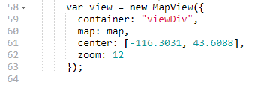

This presents an easy mechanism to link the two capabilities.
  - First, we must make sure the Layer example has the necessary parts to enact a popup. This means we must add the Locator tools to the Layer project. In the require block of the Layer example, copy the Locator parts into the Layer example:
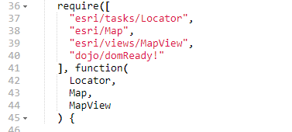

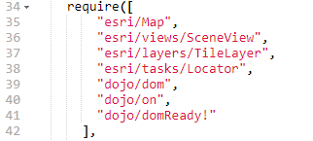

Now we can add the functionality of popups to the Layer example.

  - We need to add the locator layer to the map. In the popup example, lines 48, 49, and 50 contain our locator layer definition.

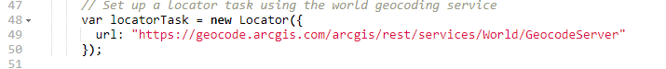

Copy those layers to the Layer Sandbox example. Let’s copy it to just below the “var view” definition in the Layer Sandbox.

  - All the click information happens in the on.click event. That function is contained in lines 71 through 95 of the Getting started with popups example.
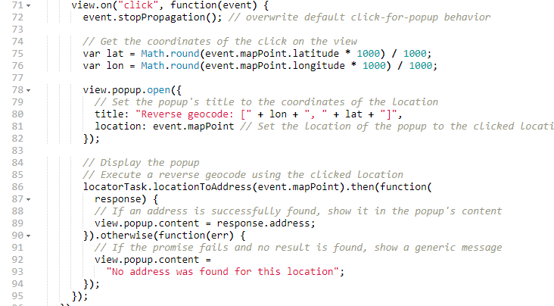

Copy these lines into the Layers Sandbox somewhere after the “var view” line. Remember scope! Don’t paste it in the middle of a function!

  - How could we go about including additional functionality into our application?

